

Travis Association for the Blind

Solution Design Document v1.0

Austin, TX

Date Created: | 04/25/2022
Date Modified: | 05/18/2022
Functional Design Sign off Date:
Detail Design Sign off Date:
Document Version: | 1.0

TABLE OF CONTENTS
INTRODUCTION 4
STATISTICS 5
TECHNOLOGY 5
KEY DECISIONS / ASSUMPTIONS 6
TERMINOLOGY 8
I. INTERFACES 9
1.0 DOWNLOAD FROM HOST TO SCALE 9
2.0 UPLOAD FROM WM TO HOST 11
II. INBOUND 14
3.0 PROCESS OVERVIEW 14
4.0 PRE-RECEIVING 16
5.0 APPOINTMENT SCHEDULING 17
6.0 QUALITY AUDIT 19
7.0 RECEIVING / PALLETIZATION 20
8.0 EXCEPTIONS 23
9.0 PUTAWAY 24
III. INVENTORY CONTROL 28
10.0 INVENTORY MANAGEMENT 28
11.0 REPLENISHMENT 33
12.0 CYCLE COUNT 35
OUTBOUND 40
13.0 WAVE PROCESSING 40
14.0 WAVE MANAGEMENT 49
15.0 WORK MANAGEMENT 52
16.0 PICKING 53
17.0 PACKING 54
18.0 DOCK MANAGEMENT 62
19.0 LOAD CONFIRMATION 62
20.0 PARCEL MANIFESTING PROCESSING 63
V. Performance Management SUMMARY 65
21.0 REPORTING REQUIREMENTS 65
VI. SYSTEM MODIFICATIONS 66
VII. OPEN ISSUES 67
VIII. RESOLVED ISSUES 68
APPENDIX A - KEY CONFIGURATIONS 69
22.0 SYSTEM KEY CONFIGURATION OVERVIEW 69
APPENDIX B – SECURITY PERMISSIONS 84
REVISION HISTORY 86
ACKNOWLEDGEMENT of Functional Flow SIGNATURE – Version 1.0 86

INTRODUCTION

This document is designed to outline the proposed global process for Supply Chain Architected for Logistics Execution (SCALE) at Travis Association for the Blind. The functional design outlined in this document is intended solely for use at the specified Travis Association for the Blind facility in Austin, TX. Future implementations at any other Travis Association for the Blind facilities will result in either change to this document or entirely new functional flows per facility.

The objective of this document is to define the systemic and functional processes and scope from a Manhattan Associates’ (MA) SCALE perspective. This document serves as a reference throughout the implementation process for confirmation of approach and definition of tasks. It will also serve as a reference for Manhattan Associates’ customer support organization (CSO) after implementation, and potentially a reference point for any future Travis Association for the Blind implementations.

STATISTICS

Basic statistics of the Austin, TX Warehouse can be found below:
- General Information
  - ~480,000 sqft.
- Outbound Volume
  - ~30k shipments per month
    - The United States Marines and United States Air Force are the main customers for Travis
- Inbound
  - ~4,000 pallets per month

TECHNOLOGY

Host: Rainbow Data Systems
Middleware: Dell Boomi
WM Platform: Windows
Version: Active SCALE 2021
RF Vendor: Zebra
MHE Vendor: Pack Size and XXX
Label Printer: Zebra (203 dpi)
Chrome Version: TBD

KEY DECISIONS / ASSUMPTIONS

- Three Storage Templates will be used for this implementation based on the lowest unit of measure for each template. The following Storage Templates will be used for this implementation:
- EA-CS-PL
- Kit-CS-PL
- Pair-CS-PL
Travis Association for the Blind will provide the conversion quantity for the non-base unit of measures. If the product is never received or shipped in a specific quantity unit of measure, then that record is not used in SCALE. EA/Kit/Pair and CS units of measure on the Storage Templates will have group during check-in set to Yes (this will group multiple EA/Kit/Pair or CS under a single LPN for putaway).
- Treat as Loose Flag will be set to Y if the product must be repacked before shipping. The Value will be set to N if it can ship in the package it is currently stored in. Treat as Loose Flag is maintained at the Unit of Measure level.
- Dimensions and weight will be gathered for all products at all utilized units of measure for a given item.
  - Dimensions will be provided at the Item Class level for most SKUs in Travis Association for the Blind’s Item Master.
- All dimensions are stored using IN (Inches).
- All weights are stored using LB (Pounds).
- Dimensions are provided for the shape the product it is shipped in. If for example T-Shirts are shipped as rolls then the dimension of the roll will be provided. The operations team can modify the dimensions directly in SCALE if required.
- The same item can come in multiple packaging types with varying dimensions. Only one set of dimensions can be configured for an individual unit of measure. Based on the dimensions assigned, SCALE will calculate location capacity (If Item Location Capacity is not set). Due to this, we might run into situation where locations are under-utilized or over filled.
- Company configuration will be used. For the Austin implementation there will be only one company defined in SCALE – ‘Travis Association for the Blind’.
- Lot tracking will not be utilized for this implementation.
- Permanent locations will be configured in SCALE for some active pick locations in the Floor Picking area (‘F’ Locations).
- Item Location Capacity records will be provided at the Item Class level for all permanent locations in the Floor Picking area.
- P&D locations will be utilized in this implementation.
  - ‘R’ locations will all have an Incoming P&D assigned.
  - An exit point has been developed by Travis which will also assign a P&D location for any movement from an ‘R’ location to any other area of the warehouse
- Serial Numbers will not be used in this implementation.
- Travis has no hazmat/ORMD requirements for any items.
- Inbound QC will not be used in this implementation inside of SCALE.
- Blind receiving will be utilized.
- Work Order and Kitting options will not be utilized in SCALE for this implementation.
- Inventory Attributes will not be used in the current implementation. Inventory attributes are specific attributes to use with specific inventory for processing reasons.
- Picking sequence will be provided by Travis to be configured in SCALE. Picking sequence is a numerical value that can be associated with locations and used in the Order by Clause to determine how Putaway and Picking should occur in the warehouse.
  - Picking sequence for the current 2016 locations will be transferred over to Active SCALE when the database is copied over.
- Item Master is currently maintained manually by Travis.
  - Existing items from the 2016 database will be copied over in the upgrade to Active SCALE.
  - New items will be manually maintained by Travis until an automated interface is developed.
- License Plate Tracking will be XXX
- Pallet Building will not be used in this implementation.
- Non-inventory items like bubble wrap and corrugate will not be tracked in SCALE.
- Location naming convention used at Travis Association for the Blind will be consistent with the existing format in the 2016 environment. Locations will be copied over during the upgrade.
- Dock assignment will be managed via Immediate Dock Transfer and Shipping Load assignment.
- Crossdocking will be XXXX
- Demand replenishment will not be used in this implementation.
- Capacity based replenishment will be used in this implementation.
- Cost and Pricing data will be present in the Item Master for use in Cycle Counting and paperwork requirements.
- Rate shopping will not be utilized in this implementation.
- Routing Guides will not be utilized in this implementation.
- International shipping will be done from the Travis Association for the Blind facility in Austin, TX.

TERMINOLOGY

Client Terminology | WM Terminology | Definition
 | NMFC | National Motor Freight Classification (LTL Class). NMFC is utilized on Bill of Lading document to display the NMFC class of the freight.
 | Wave | A wave represents the different steps that the system uses to retrieve orders from the pool, and process them into the outbound portion of SCALE
 | Override Data Wave Step (ODWS) | This wave step allows you to update data (that you normally would not have access to) during the wave process
 | Status Flow | A status flow is a defined sequence of statuses grouped together to manage processing
 | LPN | License Plate Number
 | VAS | Items that require special handling
 | P&D | Pick up and Drop location
 | UI | User interface
 | ASN | Advance Shipping Notification
 | PO | Purchase Order
 | HazMat | Hazardous Material
 | EXIT Point | External process that performs logic in line of the base process. Used to update data or perform additional logic.
 | MIF | Manhattan Integration Framework
 | UDF | User Defined Field

INTERFACES

Travis downloads & uploads information into SCALE using XML file-based methods of interfacing.

Note: This is a change from the 2016 direct to table methodology.

This allows Travis to create records with key information for downloads, and SCALE reads this key information to process the download into the SCALE production tables. This method also allows Travis to read key information from SCALE’s upload interface records.

Each interface touch point below can be run manually as well as through scheduled jobs as defined by Travis Association for the Blind. The specific schedule can depend on the Host System, warehouse processing times, and SCALE interface execution times.

Warehouse alerts can be configured to notify Travis when a download or upload interface transaction has failed for any reason.

DOWNLOAD FROM HOST TO SCALE

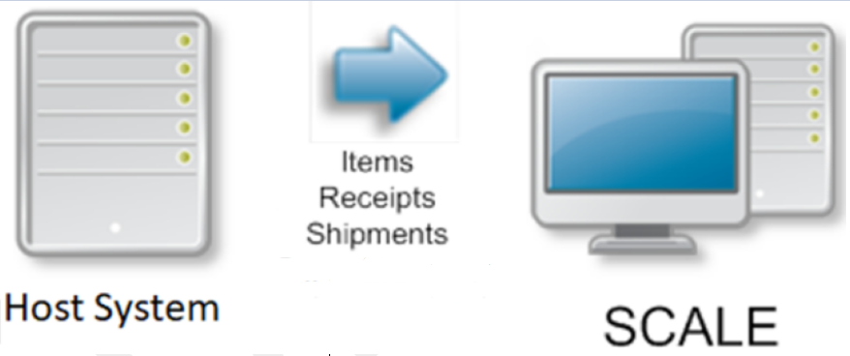
Figure: Download Touchpoints

Item Master

In the existing SCALE 2016 environment, Travis does not utilize the Item Download interface touchpoint and instead will manually configure all new items as they arrive at the facility (including all item category, UDF, and characteristic information).

As part of the conversion to Active SCALE, Travis would like to develop an Item Master download approach where the host system downloads a record into SCALE when an item is modified or created. If an item already exists in the Item Master, then the record is flagged as a change and SCALE updates the existing item with the new information bridged down.

Note: Item Unit of Measure information is maintained at the Item Class level for most of the SKUs in Travis’s inventory and this approach will not change in the transition to Active SCALE.

SKUs at Travis are referred to internally as NSNs and this terminology may be used throughout the remainder of this document.

Some key Item elements maintained by Travis are:
  - Military Branch
    - Item Category 1
  - Item Class
  - Issue Type
    - Item Category 2
  - Putaway Zone Designation
    - Item Category 5

Receipts

In the current SCALE 2016 environment, Receipts are not interfaced to SCALE until the product arrives at the warehouse and the TCN is given to the Travis receiving team. After the team receives the TCN, they will enter this into VIM (Vendor Identification Module) which kicks off the download process to get the Receipt into SCALE.

In the future state with Active SCALE, Receipts will be interfaced for all vendors shipping product to the Travis DC via an XML file-based approach. This data will be sent upon consumption of the EDI transaction in the Travis host and may sit in SCALE until the product arrives at the warehouse physically. The information downloaded to SCALE from Travis will always contain both header and detail level information. Container Level Receipt data will not be sent to SCALE.

SCALE Table | Description
Receipt Order Header | Header Level Receipt Data
Receipt Order Detail | Line-Item Detail Receipt Data

Shipments

In the existing SCALE 2016 environment, Rainbow Data Systems is responsible for handling the conversion of EDI transactions to send CSVs to Travis, which are then inserted via Direct to Table interfaces with the SCALE DB.

As we transition to Active SCALE, the EDI files produced will flow through Boomi which will be responsible for any conversion/formatting required. Once formatted, the Shipments will be passed onto SCALE via XML file-based interfaces. Shipment data is sent with a warehouse-specific shipment header, one or more shipment details, and optional shipment comments. The shipment header contains information such as customer, customer address, ship to address, carrier, and scheduled ship date information. The shipment detail is the item level detail for the shipment containing information such as item and ordered quantity. Comments can be linked to the shipment header or details to validate additional processing requirements within the warehouse. Until the shipment has been waved, SCALE can process updates and deletions from the host against the shipment.

Two main types of shipments will be sent to SCALE from Travis:

- Parcel Shipments (UPS)
- LTL Shipments

SCALE Table | Description
Shipment Header | Header Level Shipment Data
Shipment Detail | Line-Item Detail Data
Shipping Container | NOT DOWNLOADED – Container Level Data
Shipment Comment | Header or Detail Level Comments

UPLOAD FROM WM TO HOST

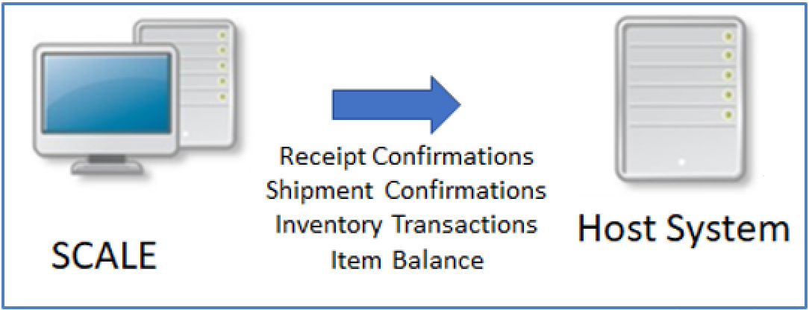
Figure: Upload Touchpoints

Receipt Confirmation

The Interface Data option creates the receipt upload files from SCALE for all receipts that have reached the trailing status ‘In Putaway’ or have been closed manually. The receipt upload files are the output of the receiving processes within SCALE. The upload includes receipt header, receipt detail, and receipt container level information. As each receipt container reaches ‘In Putaway’ status (Container Level Upload), the interface sends information to the host system to allow that receipt’s inventory to be acknowledged as present in the facility.

For Travis Association for the Blind, the upload will be performed at Container level when the status of the receipt reaches ‘In Putaway’.

Note: This represents a shift from the existing SCALE 2016 process which generates uploads at the Detail Level when the detail reaches a status of ‘Putaway Pending’.

Additionally, the Receiving Dock Location Class will be configured to have its inventory excluded from the Item Balance upload for Active SCALE.

Shipment Confirmation

The Interface Data option creates the shipment upload files from SCALE for all shipments that have reached status ‘Closed’ (shipment has been loaded to the truck and truck has left the warehouse). The shipment upload files are the output of the outbound process within SCALE. These files are generated after the execution of the Shipping Load confirmation. The upload includes shipment header, shipment detail, shipment comment, and shipping container information.

For Travis Association for the Blind, Shipment uploads are created only at Closed (900) status.

Inventory Transactions

SCALE maintains 4-wall inventory at a detailed level and communicates any changes in inventory levels to Travis through the Inventory Transactions Interface. All movements and changes in inventory are eligible to be uploaded (Adhoc adjustments, cycle count adjustments, status changes, etc).

Item Balance

The total on-hand inventory for a given item and inventory status can be uploaded to the host system on-demand through the Interface Data option in SCALE, or on a scheduled basis as configured in the Scheduled Job option. Any time the total on hand quantities are needed to compare against the host system, this option can be run and sent to the host for reporting & comparison purposes.

Note: Travis uses the Inventory Status field in SCALE to represent the Condition Code of inventory in the facility and needs to retain this information in the Item Balance all the way through the Shipping Dock locations. To accomplish this, Travis will need to call a modified version of the base Item Balance stored procedure which will be handled via EX-XXX.

Update and Delete for the Download Touchpoints

As part of download interface SCALE allows Travis to modify or delete the records that were interfaced to SCALE. There are certain validations that SCALE performs before allowing these changes. The validations are as follows:

- Receipts in SCALE can only be Updated/Deleted when the Leading and Trailing status are Check-In Pending.
- Shipments can only be Updated/Deleted when both the Leading and Trailing status of the shipment are in a status of ‘In Pool’.

Based upon the Action Code sent as part of the interface, SCALE determines what action (NEW, SAVE, CHANGE, or DELETE) needs to be carried out.

II. INBOUND

PROCESS OVERVIEW

Travis Association for the Blind will perform all standard receiving (non-returns) as Item Level Receiving. For all vendors, once the EDI transaction has been sent to Travis, it will get communicated down to SCALE via the Receipt Download touchpoint.

Once the above steps are complete, the Receiving Worksheet can be printed to assist in the receiving process. The Receiving Worksheet is an optional part of the process as most of Travis’s vendors currently send a Packing List with the inbound shipment.

Note: For Travis, a 1348 Document will be sent with any return arriving at the warehouse and a DD250 will be sent with all standard receipts sent to the facility. For this reason, unless there is missing paperwork, the SCALE Receiving Worksheet will not be utilized in the Travis receiving process.

Each SKU is then unloaded off the truck(s) and sorted onto single SKU pallet(s) for locating and putaway. After the pallet(s) have been located during the check-in process, a work task will be created for the user to bring each pallet to its final inventory location.

Each step mentioned in the overview is described in detail in the sections below.

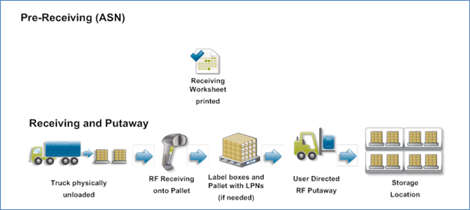
Figure: Receiving Process
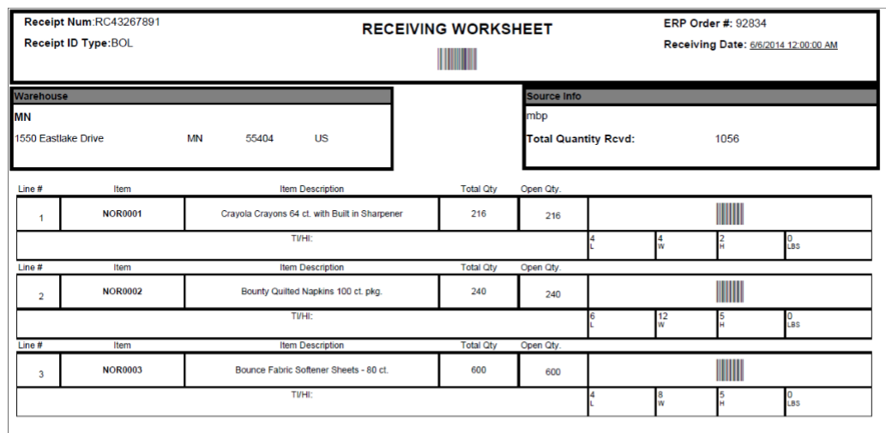
Figure: Receiving Worksheet Sample
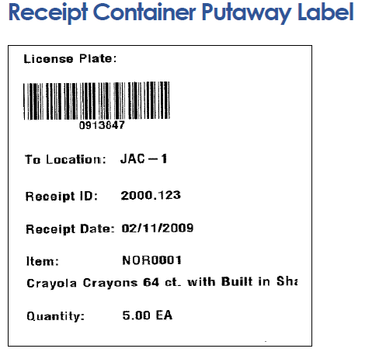
Figure: Receipt Container Sample Label

PRE-RECEIVING

Receipt Creation

Interface

Travis will produce Receipt download records that are interfaced to SCALE for all vendors. Most returns will be interfaced to SCALE (some unauthorized returns will not be sent via interface), and these will be processed in the same manner as standard receipts. For any unauthorized return, Travis will either manually create the 1348 (receipt in SCALE) or utilize a Blind Receiving option to bring the goods into the facility. The interfaced records will then be processed and validated through the SCALE interface to ensure the data format is correct.

Note: Blind Receiving will not be supported in Warehouse Mobile for the initial go-live date. To support this process, Travis will make use of Blind Receiving either from the full screen SCALE UI (Receipt Workbench) or utilize a specific RF device which will be setup to run the legacy RF until the functionality is available in Warehouse Mobile.

Receipt Types

In order to group receipts together in the SCALE insight screens, and potentially to drive processing rules, it is helpful for SCALE to store different Receipt ID Types and Receipt Types.

The following list of Receipt ID Types will be configured in the system:

- DD250
- 1348 (Returns)

Viewing Receipts

All receipts that are downloaded or created manually in SCALE can be viewed from the Receipt Insight Option.

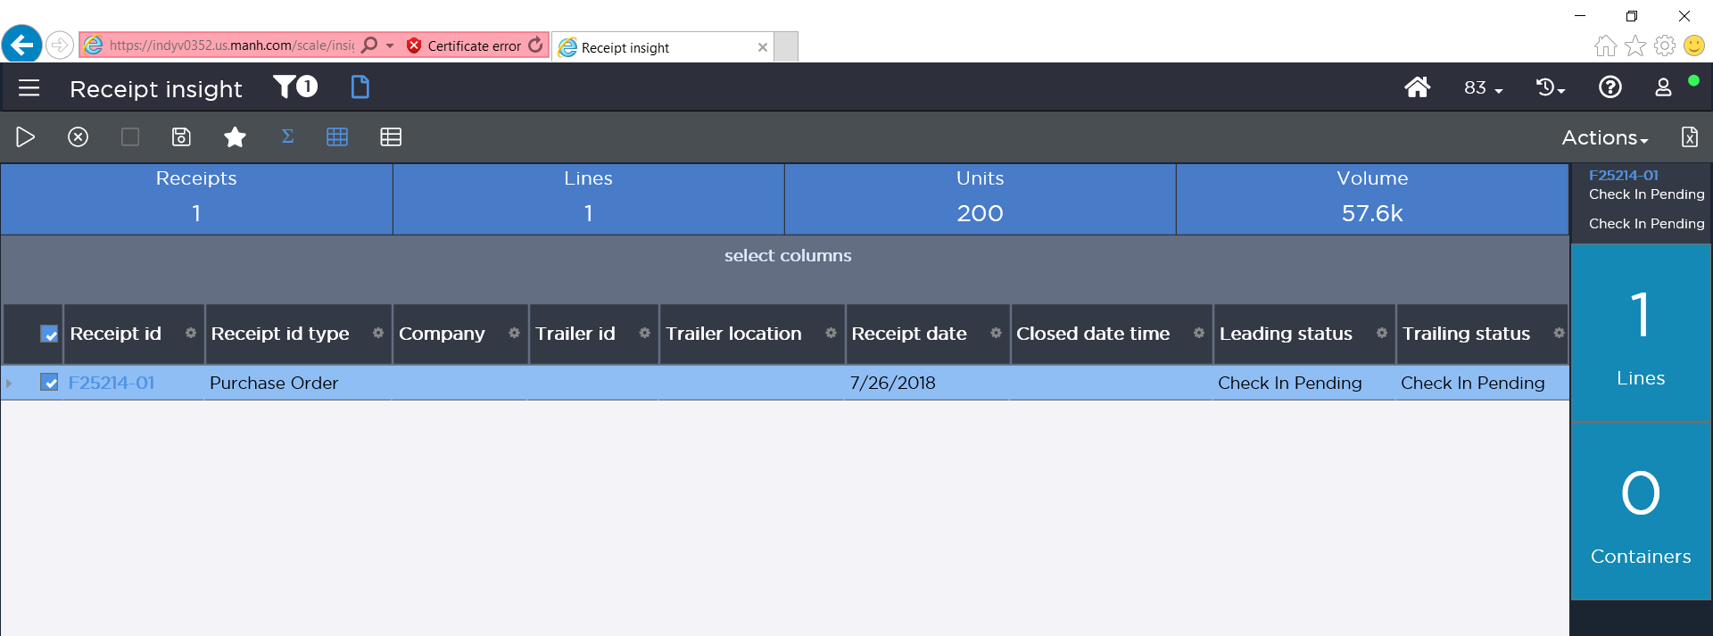
Figure: Receipt Insight

Generate Receiving Documents

Once a receipt has been created, documents can be printed against it. A Receiving Worksheet (DOC01) that contains various data elements from the receipt can be printed from SCALE by selecting a receipt in the Receipt Insight screen and choosing the ‘Print Selected Documents’ option from Actions. Travis Association for the Blind may choose to use the Receiving Worksheet to aid in the systematic receiving process at some point, but this will likely not be utilized for the initial go-live.

APPOINTMENT SCHEDULING

Operations

Once a receipt has been created in SCALE, appointments can be scheduled against it from the Receipt Insight. As appointments are known, users can schedule those appointments within SCALE by searching for the receipt, selecting it, and then choosing the Schedule Appointment option.

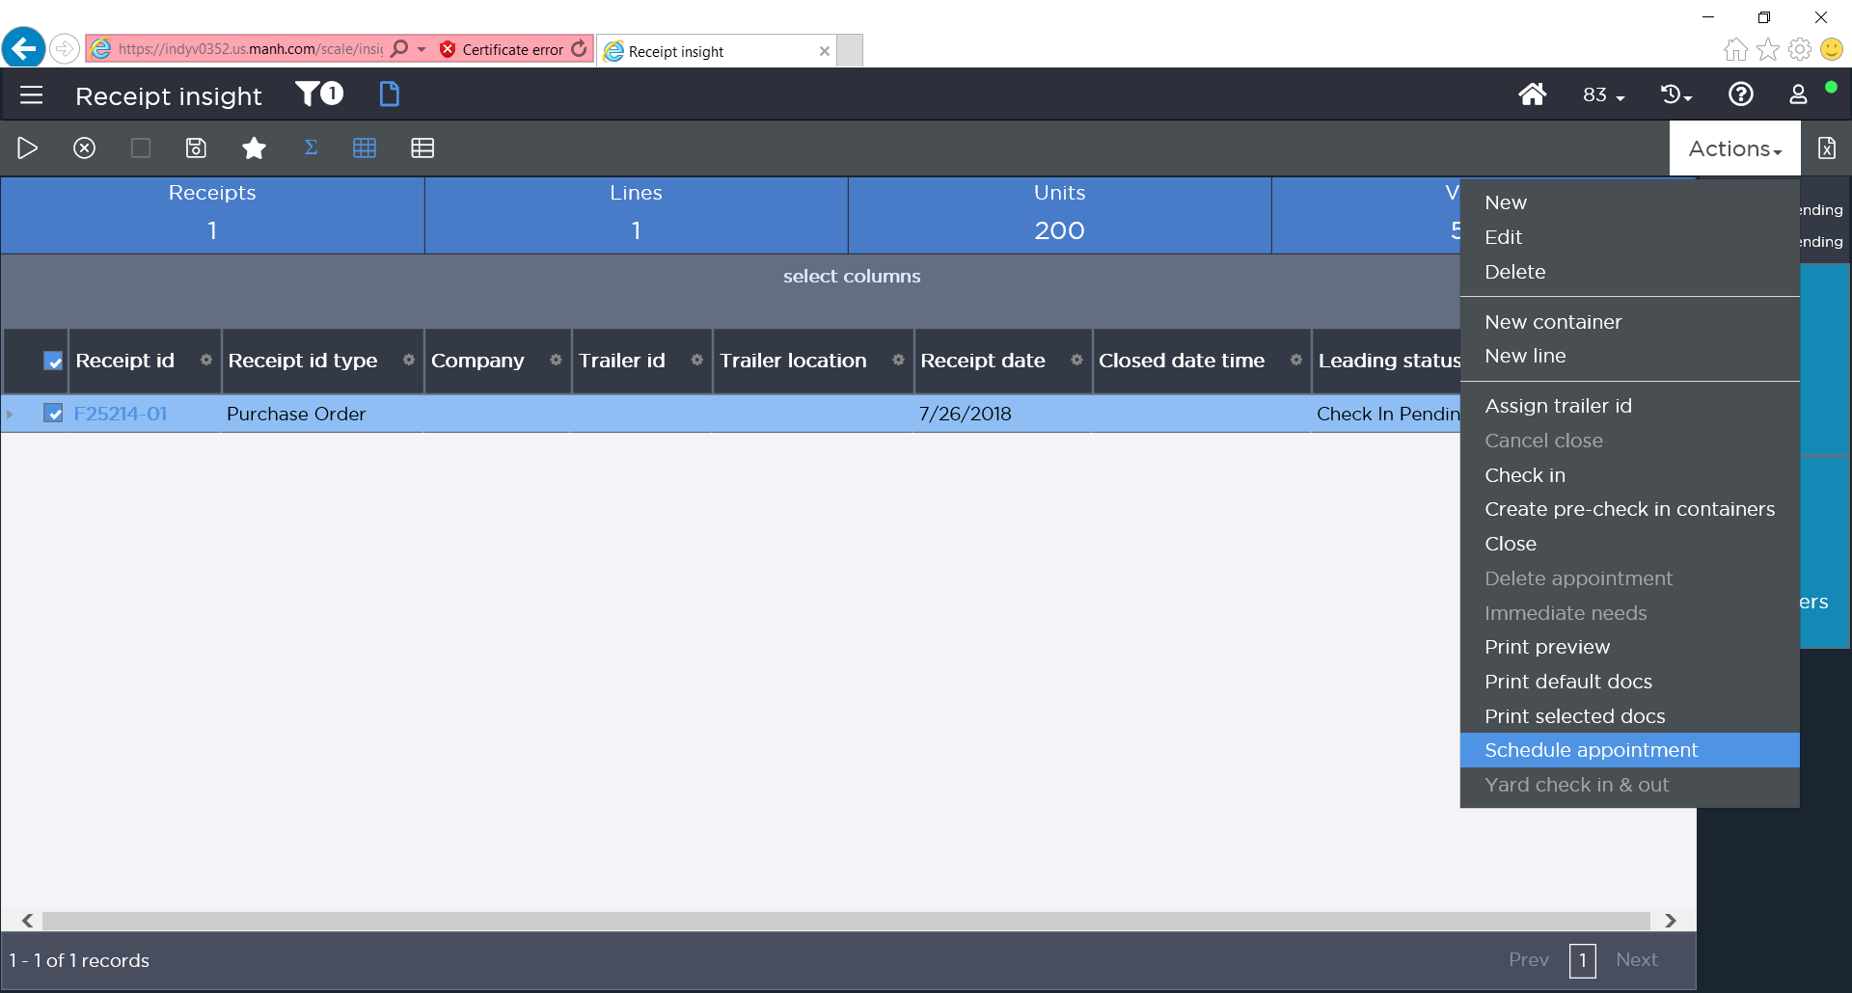
Figure: Receipt Insight – Schedule Appointment Option
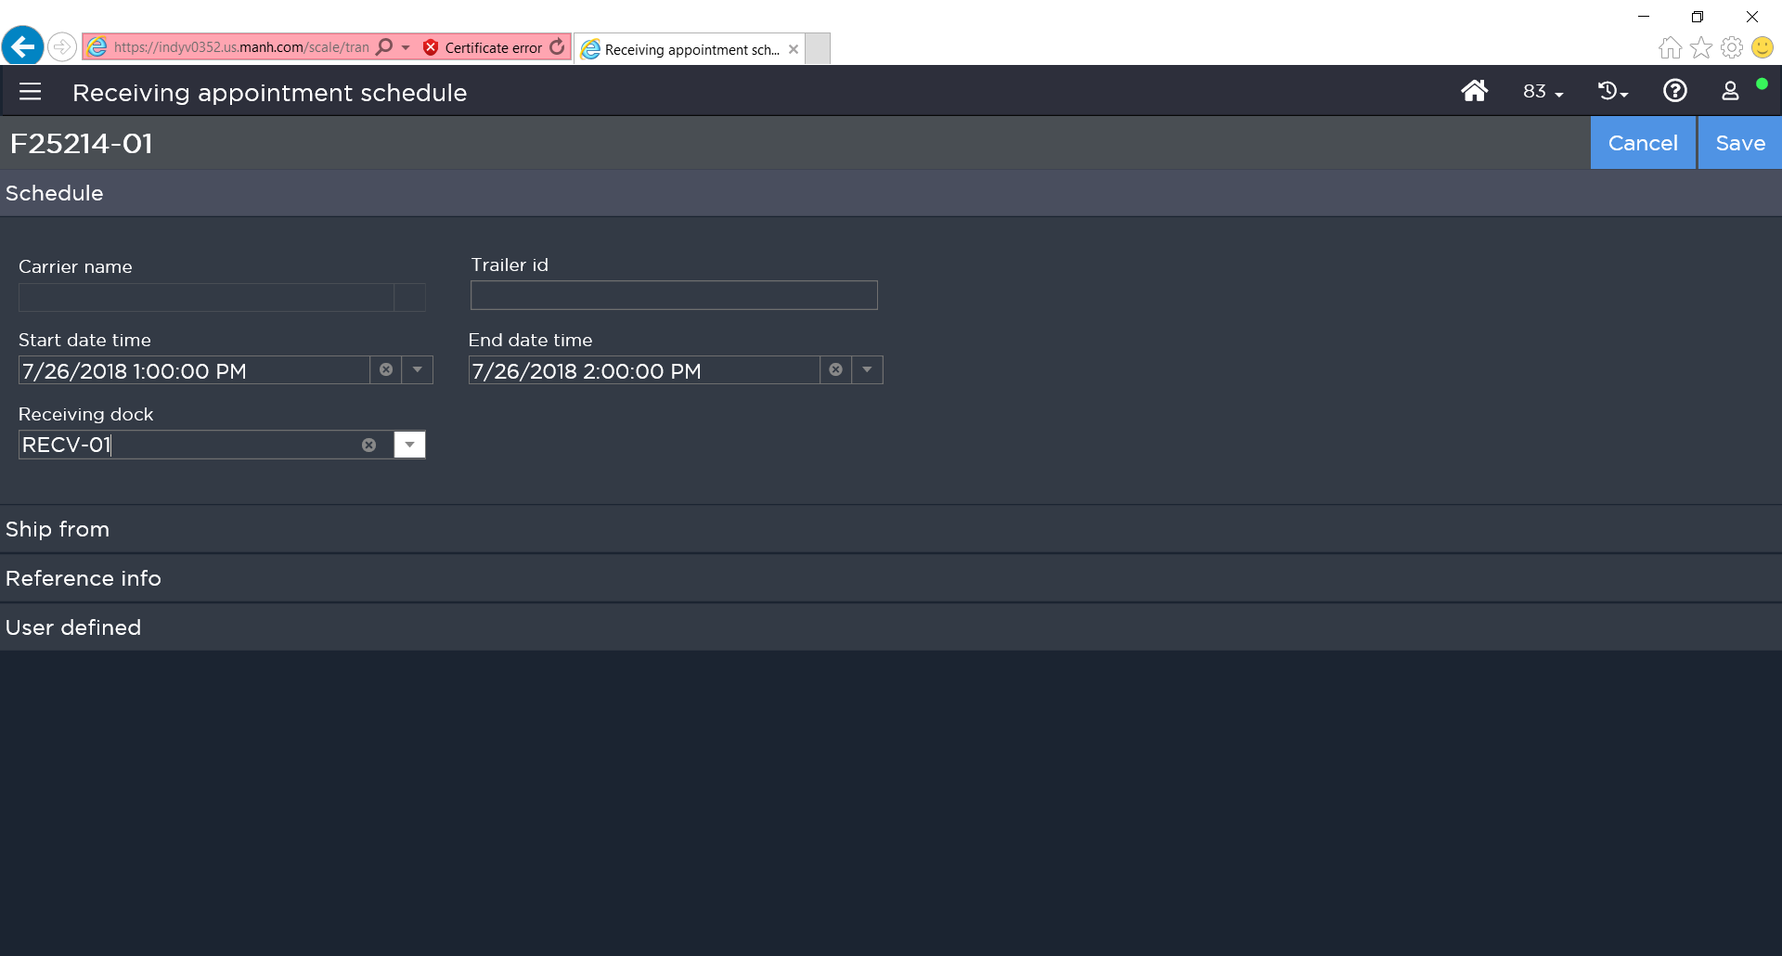
Figure: Receiving Appointment Schedule Window
This allows for enhanced management of receiving dock door locations, as well as the personnel required to unload the trailers at the dock. Users may enter the following information when scheduling an inbound appointment:

- Trailer ID
- Dock Door
- Start Date/Time
- End Date/Time

Note: Appointments can only be scheduled for open receipts in SCALE. Appointments cannot be created without associating a receipt to the appointment (cannot be created for POs).

Dock schedules can be viewed from the Appointment Calendar. This screen offers a view into daily appointments for each receiving dock location.

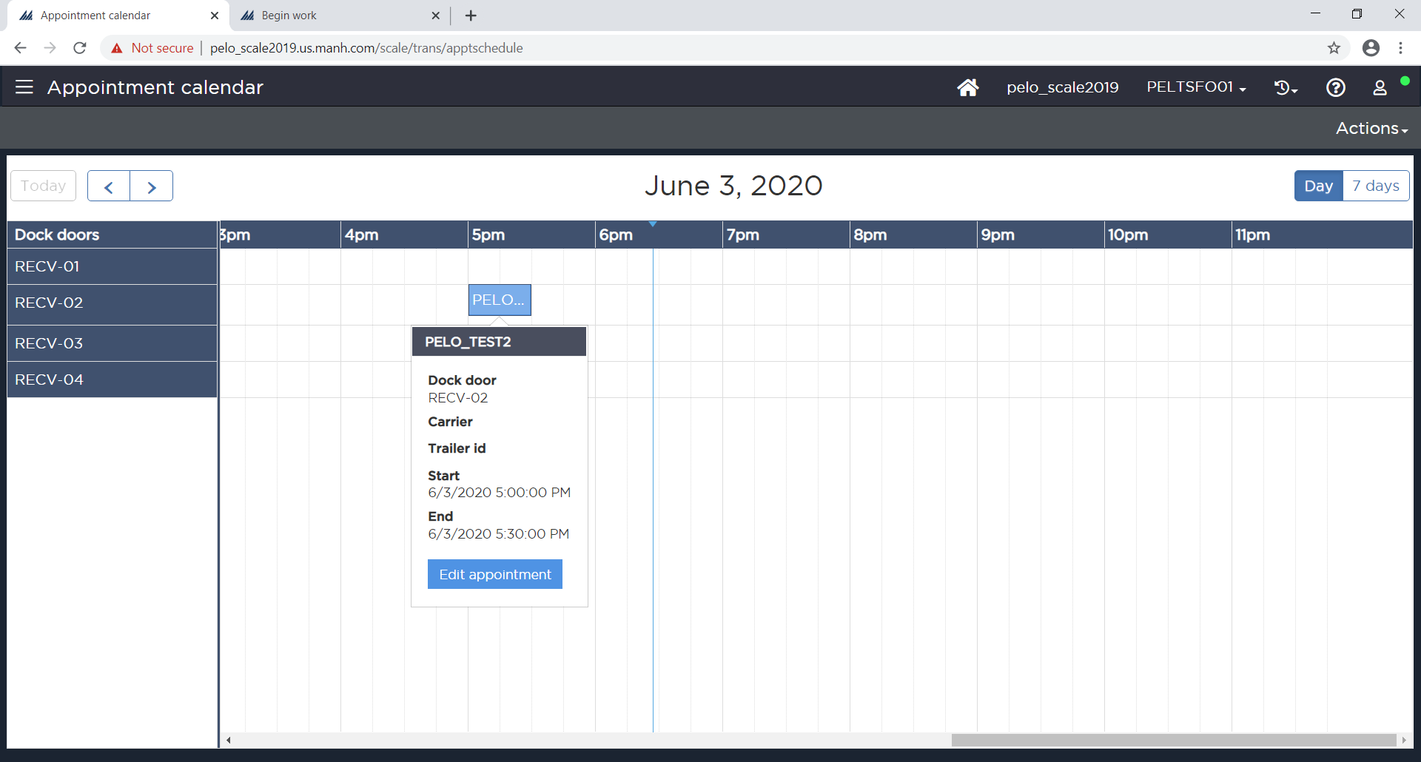
Figure: Appointment Calendar
Scheduled appointments can also be deleted from the Receipt Insight by searching for the receipt, selecting it, and choosing the Delete Appointment option from the Actions menu. Scheduled appointments can also be edited using the Appointment Calendar screen directly.

QUALITY AUDIT

Inbound QC

Travis Association for the Blind does not execute any form of inbound QC inside of SCALE and will not for the initial conversion to Active SCALE.

RECEIVING / PALLETIZATION

Item Level Receiving

Item Level Receiving will be used for all Receipt Types in SCALE.

Item level Receiving will be performed from either the full screen Receipt Workbench UI or directly on the RF devices in Warehouse Mobile. Below is the recommended approach for executing Item Level Receiving.

All Item Level Receipts
- User will first begin the receiving process by optionally printing the Receiving Worksheet from Receipt Insight. If the user does not print the Receiving Worksheet, they may use the vendor provided documentation instead (TCN, DD250, or 1348).
- The user will then receive the items onto single SKU pallets to await putaway.
- At the time of check-in, SCALE will utilize the configured locating rules to select a suitable putaway location for the pallet/cases and generate the work task for the user to complete
  - NOTE: Receipt Uploads will be generated at the Container Level when the each receipt container (PL, group of CS/EA, etc) reaches a status of ‘In Putaway’ or greater.

The user first navigates to the Receipt Insight screen from the SCALE web UI. The user will then begin the receiving process by selecting the receipt they wish to receive against and optionally printing the Receiving Worksheet (DOC01). Once the Receiving Worksheet is printed, or documents from the vendor collected, the user can proceed with processing the receipt via the full screen UI or begin receiving from the RF device using Warehouse Mobile. For all line level receipts, the user will begin by using the Item Level Receiving Preference on either the SCALE insight screens or Warehouse Mobile. In the full screen, once the receiving preference is selected, the user will be presented with the Receiving Workbench insight screen where they will select which line they intend to receive and begin the check-in process.

In the Warehouse Mobile driven workflow, after the user has selected the Receiving Preference they wish to use, they will be presented with an input box asking them to specify the Receipt ID they wish to receive against. After the Receipt has been specified, SCALE will prompt the user to enter the item they wish to receive before the remainder of the check-in process is completed. If the item does not have dimension information, has missing dimension information, or no unit of measure information, the system notifies the user of this through an error message. The user will be able to continue receiving as this missing dimension error message is a soft stop. License Plate assignment will be set to System meaning SCALE will generate a license plate value for each Receipt Container received and print the Receipt Container Label after check-in is complete (LBL01).

After the information for the item is entered, the inventory received will be in ‘Putaway Pending’ status. From here, when the user is ready, they can switch to the LPN Putaway Work Profile in Warehouse Mobile to execute the putaway of each pallet (pallet in this context can be a full PL or grouped CS/EA quantity) from the Receiving Dock to the selected inventory location.

Note: Receiving Preference for Item Level Flow - RF Workflow will be set to Header – Item no Disposition Code, Check-in and Locate (Immediate), Execute Group Putaway option unchecked, Process Immediate Needs unchecked

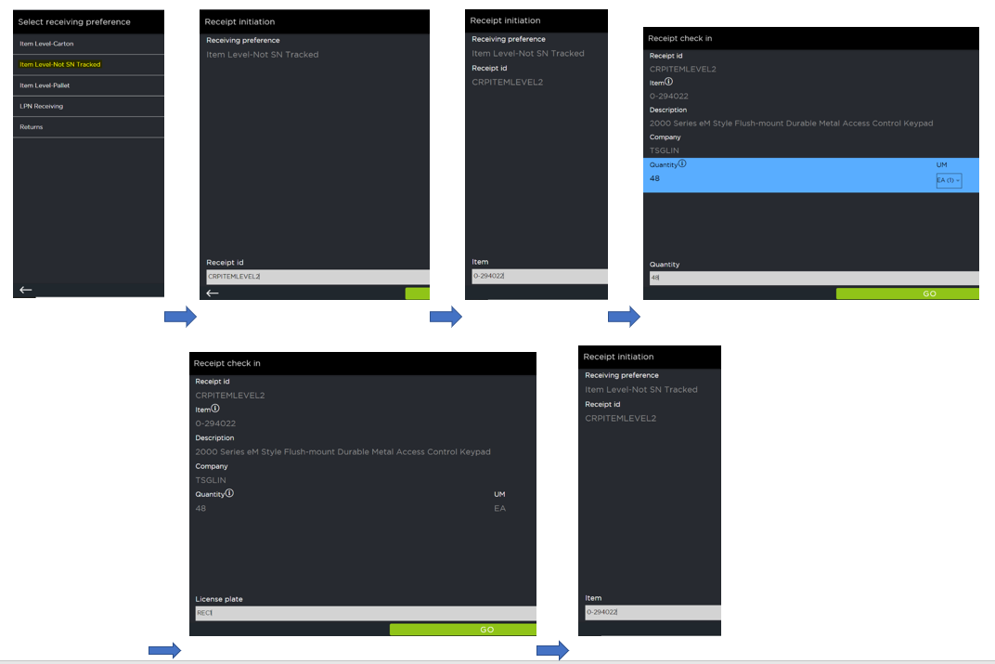
Figure: Warehouse Mobile Item Level Receiving

Returns Receiving (Blind Receiving)

Any unauthorized return for Travis will show up at the facility without any 1348 having been created in the host ahead of time. In these instances, Travis still needs to be able to receive the product back into the warehouse. This will be accomplished in one of two ways in SCALE:
- Manually create the 1348 as a Receipt using the Receipt Insight screen and utilize the standard Item Level Receiving preference to process the goods.
- Blind Receiving Preference
Blind Receiving allows the user to receive product when no Receipt is present in SCALE ahead of time. This process will create a new Receipt on the fly while the user is receiving and will allow them to change the defaulted name of this Receipt during the beginning of the check-in process. This process will be executed by users on the RF device under the Receiving -> Returns Receiving menu option in Warehouse Mobile.

Note: Blind Receiving will not be supported in Warehouse Mobile at the time of Travis’s initial go-live, and as such, will be handled via full screen in the Receipt Workbench UI or on an RF device which is configured to run the legacy RF. Travis will transition to using Warehouse Mobile for Blind Receiving as soon as it is available in Active SCALE.

When the user begins this process, SCALE will supply a next up Receipt ID which the user can accept or edit to reflect the desired nomenclature. After the user has confirmed the Receipt ID they wish to use, the receiving process will proceed the same as the standard Item Level Receiving process defined in Section 7.1, but after check-in the user will be asked to supply a disposition code for the LPN being received.

Note: Receiving Preference RF Workflow will be set to Blind with Disposition Code, Locate by Child, and Execute Group Putaway option unchecked.

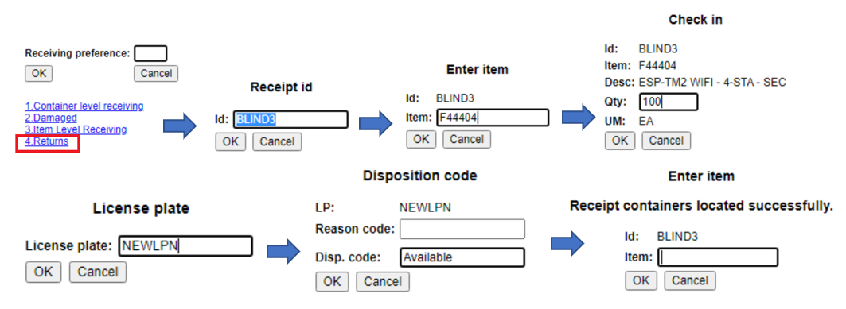
Figure: Returns Receiving Process

Damaged Receiving

If a product shows up to the Travis facility in a damaged state, depending on the type of Receipt it arrives on, Travis will handle the inventory in one of two ways:

- DD250 Damages (Standard Receipts)
  - Travis will receive all inventory in full under ‘A’ status prior to executing a Status Change transaction on the damaged portion of the receipt
- 1348 Damages (Returns)
  - Will receive the goods directly into a damaged/unavailable status through either the Blind Receiving preference or standard Item Level receiving

Verify Receipt

For receipts where all receipt details are received complete, SCALE automatically closes the receipt upon the putaway of the last LPN. Upon confirmation of the close, SCALE updates the receipt status to Closed and does not allow additional product to be received.

Receipt Upload: SCALE will upload header/detail/container level information to the host when each receipt container hits ‘In Putaway’.

EXCEPTIONS

Overages

Over Receiving is not allowed at Travis for any DD250. If the vendor sends an overage for any item on the receipt, Travis will file an SDR for the excess quantity and send the overage back to the vendor.

For 1348s, over receiving is allowed and will be processed using SCALE.

Shortages

For any short receipt at Travis, the standard procedure is to leave the shorted receipt open until the vendor has sent the remainder of the units. Based on the Archive Master settings, if the vendor does not send the remaining inventory within 3 months, the receipt will be archived and need to be redownloaded to SCALE.

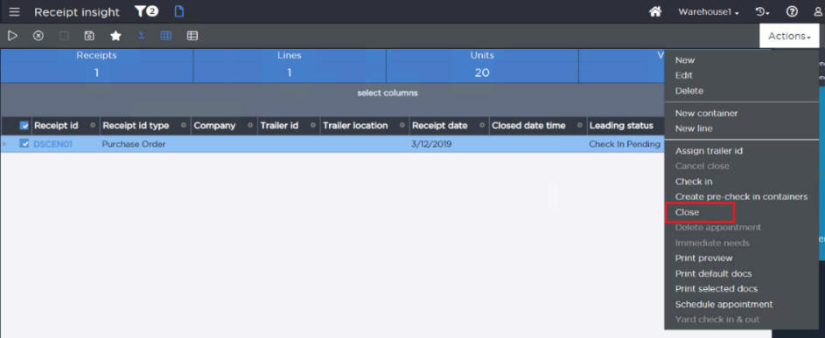
Figure: Receipt Insight – Close Option
Note: If a receipt were to be accidentally closed, SCALE does allow the user to manually re-open the receipt.

Damages

Damaged goods will be handled according to the process defined in Section 7.3.

PUTAWAY

Locating Rules

Once inventory has been checked in to SCALE, a putaway location is found using locating rules. Travis Association for the Blind already has locating rules in place from the SCALE 2016 solution which will be copied over during the upgrade process. To allow for easy addition of new items and locating rules, the locating rule is assigned on the Receipt Detail using the Locating Rule Assignment configuration. Travis can still manually set the locating rule after the Receipt Detail is downloaded by opening the receipt line and selecting a different locating rule.

While the locating rules/zones will be copied over from the 2016 database, the following options will be reviewed during the Build Phase as potential enhancements to the existing rules:

- Utilize the ‘Fill one and only one location within the location selection’ strategy for locating into the ‘F’ section of the facility.
- Utilize SCALE generated License Plates during receiving in conjunction with enabling ‘Split Quantity’ on the locating rule details.
  - Print Receipt Container Labels from SCALE (LBL01)
- Review existing rules for consolidation opportunities.

 | Locating Zone | Description
1 | Mirror Existing SCALE 2016 Locating Zones (will be copied over during DB upgrade) | - Zone Dependent

Locating Rules for Directed Putaway

- Initial locating rules for go-live will be copied over during the database upgrade from 2016 to Active SCALE.

Putaway Work Creation

Upon the receiving and palletization of the items, SCALE generates system work records for each located LPN. For full or partial pallets, the work unit will be the LPN which will be printed on the Receipt Container Label generated by SCALE during the check-in process.

Warehouse Mobile Putaway

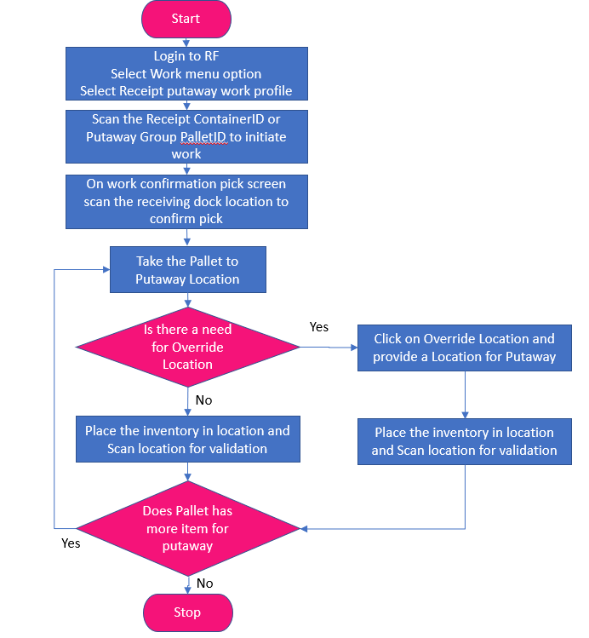
Figure: Warehouse Mobile Putaway Work Execution Flow
To initiate putaway work, Travis Association for the Blind personnel will utilize the Putaway Work option in Warehouse Mobile. A user enters the number associated with the Putaway Work Profile selection or chooses the profile by scrolling through the list of Work Profiles. Upon selection, SCALE prompts the user to enter a work unit, which in this scenario would be the Pallet LPN (partial or full).

Upon scanning the barcode, SCALE assigns the work unit to the user. SCALE then displays the current receiving dock location with item information and prompts the user to confirm the number of units associated with the work unit (units on the LPN). Upon confirmation of the contents, SCALE updates the LPN(s) to status In Putaway and displays the putaway location for the first item. To complete the putaway, the user takes the pallet to the directed location where they can then scan the location for validation of the putaway.

Note: For Travis, all full PL putaways will direct the user to first drop the pallet to the ‘Conveyor’ location which represents the induction point of the inbound conveyor. From there, the inbound conveyor will drop the pallet to the correct spur (P&D) location based on the data present in the TRAV_PALLET table in the SCALE database (EX08 – SCALE 2016 Extension). Finally, a forklift user will pick up the pallet from the P&D to complete the putaway to the correct reserve location.

Any partial pallet created during receiving will be located directly to an inventory location (ILA if available) and putaway by LPN (work unit).

The user may skip the putaway instruction and proceed to the next item on the work unit if multiple work instruction lines exist (i.e. more than one putaway location assigned or multiple items on a Putaway Group). This is done by using the Skip button. If the user skips the putaway, the system continues to direct the user through the putaway locations in putaway sequence (LIFO on the pallet for Putaway Groups) before looping back to put away the skipped items.

Upon putaway to the final inventory location, SCALE updates the LPN to status Closed and updates the on-hand quantity at the final inventory location.

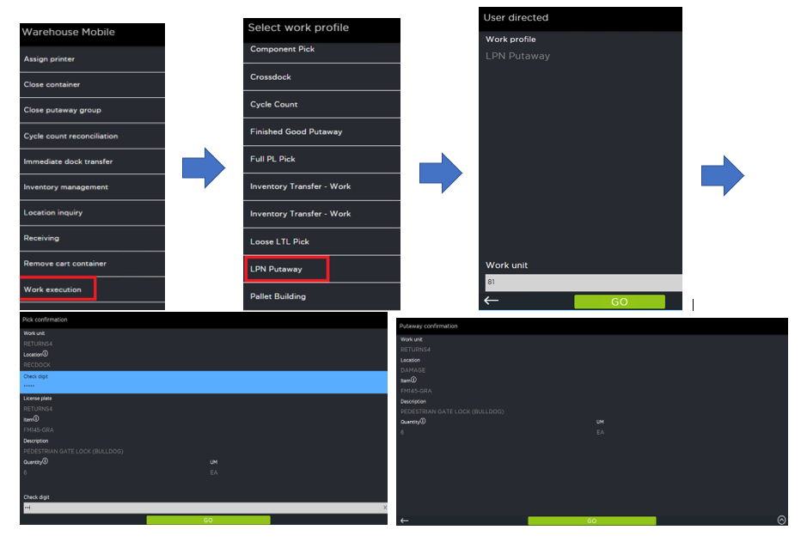
Figure: Warehouse Mobile Receipt Putaway Work Execution

Location Override

Certain users can be granted security permissions to override the systems suggested location for the inventory. If this needs to happen, the user picks the LPN from the receiving dock, just as with the other work; however, when they are prompted for the Putaway Screen the user chooses the Override action from the menu in Warehouse Mobile.
This will redirect the user to a screen where they can scan/enter the location name from the location in which they want to physically put the product away. The system validates that there is nothing else directed to that location and that the location is valid before accepting the user’s override. After validation passes, the system updates the work record, the LPN to note the new location, and writes Transaction History noting the change in the putaway location. Finally, the user is presented with the Putaway Confirmation screen where they complete the putaway in the same manner as standard work units where no override took place.

When a user presses the Location Override button on the screen, after the user is redirected to the override screen, the user also has the option to click on the ‘Locate’ button. When the ‘Locate’ button is pressed, the user is presented with an option to select a locating rule. The system will then decide a suitable putaway location based on the locating rule selected by the user.

Note: The user will be manually selecting the locating rule that SCALE will use to find a location for putaway in this scenario.

If the user selects the option to override, SCALE has ability to create an activity-based cycle count at the original putaway location. Travis Association for the Blind does not currently use this option.

III. INVENTORY CONTROL

INVENTORY MANAGEMENT

Inventory Adjustment

Inventory adjustments either increase or decrease the on-hand quantity of an item in a location. The adjustment types are configurable and are created to indicate reason codes for the associated adjustment such as Damaged, Scrap, etc. Each adjustment type can be set up to have minimum and maximum adjustment quantities. Security is maintained to control which users have access to which adjustment types. Adjustment types can be configured to either generate uploads for the host or update only SCALE inventory without an upload being generated.

All adjustments are entered in the Inventory Management option. This option can be initiated blindly from the insight screen main menu or the Inventory Management option in Warehouse Mobile. It can also be initiated by selecting a location/item combination in the Inventory Insight Screen. Personnel may then proceed by entering the quantity to adjust, where the quantity is specified as a negative value for negative adjustments. After confirming, SCALE adjusts the inventory in the location and creates a history record for the inventory transaction.

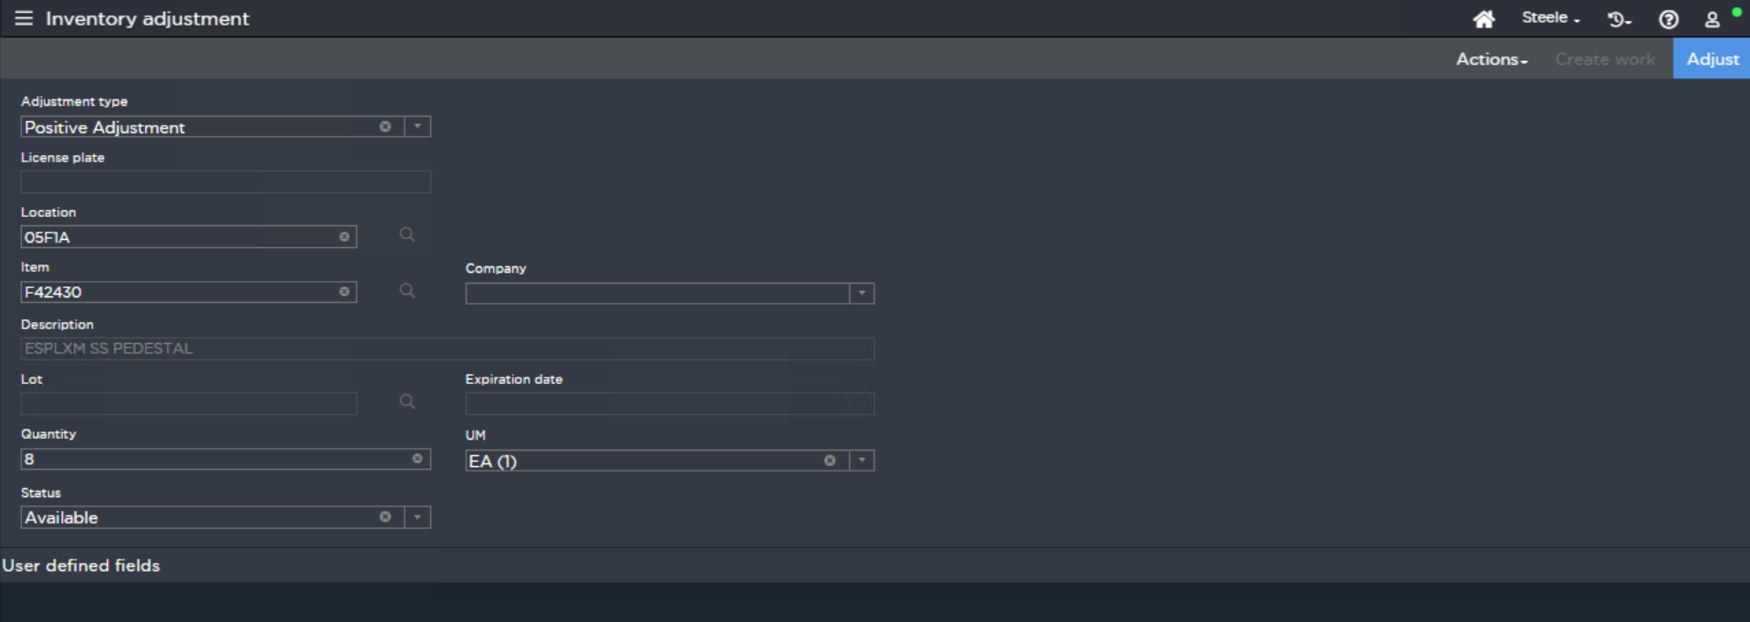
Figure: Inventory Adjustment Insight Screen
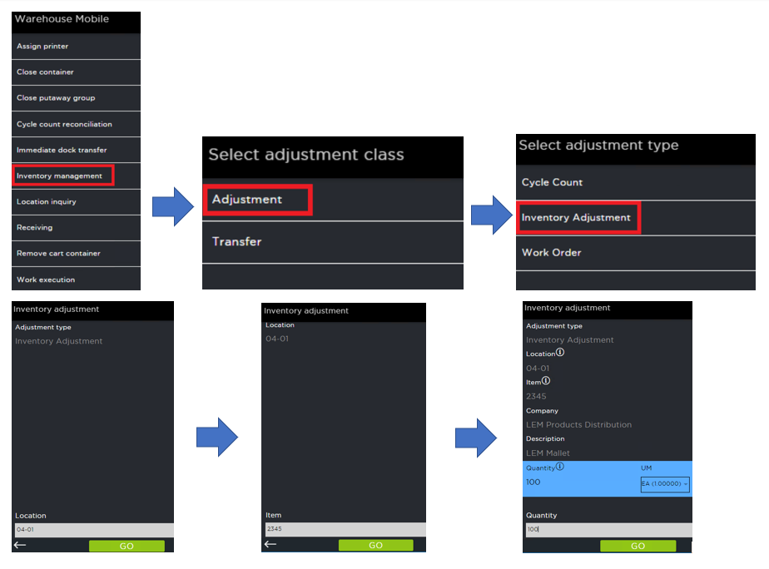
Figure: Inventory Adjustment via Warehouse Mobile Inventory Management Option
Note: Inventory cannot be adjusted in the receiving dock locations. Only located items can be adjusted using Inventory Management.

Adjustment Types

  - Copied from existing SCALE 2016 environment

Inventory Transfer

Inventory transfers move the on-hand quantity of an item from one location to another within the four walls of the warehouse. The transfer types are configurable and are created to indicate reason codes such as Consolidation, Back to Stock, etc. Each transfer type can be set up to have minimum and maximum transfer quantities. Security is maintained to control which users have access to which transfer types.

The Inventory Transfer option can be initiated blindly from the insight screen main menu or Warehouse Mobile Inventory Management. This can also be initiated by selecting a location/item combination in the Inventory Insight, in which case the “from location” and item are automatically defaulted. In the scenario where Inventory Management is blindly initiated, the user is required to specify the “from location”, item, and quantity being transferred.

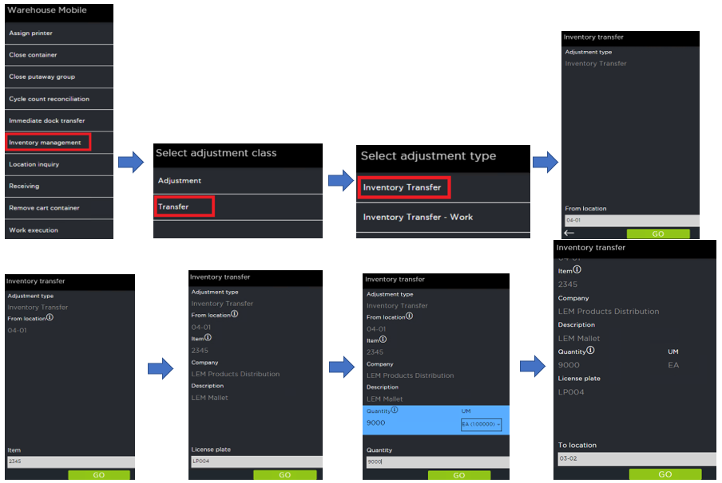
Figure: Inventory Transfer via Warehouse Mobile
As part of the inventory transfer process, users can also choose to create work. This way, a supervisor can decide what inventory needs to be moved and then a user on the floor will get the work task to physically move the product. Inventory transfer with work must be created from the insight screens. The work execution can happen on the RF device or be confirmed through the Work Insight Screen.

Transfer Types

  - Copied from existing SCALE 2016 environment

Note: As part of the upgrade to Active SCALE, Travis would like to setup a Transfer Work Profile which is user directed and will not interfere with the existing Cycle Count Work configurations which use ‘From Loc’ as the Work Unit value. To do so, a new user-driven Transfer Work Profile will be setup with ‘From Check Digit’ as the Work Unit value to ensure unique work units across work types.

Additionally, Travis would like to leverage the Work Creation – After Exit Point (EXP01) to remove the P&D assignment from any Transfer Work with a ‘To Location’ in the R1 area (Floor Level Racking).

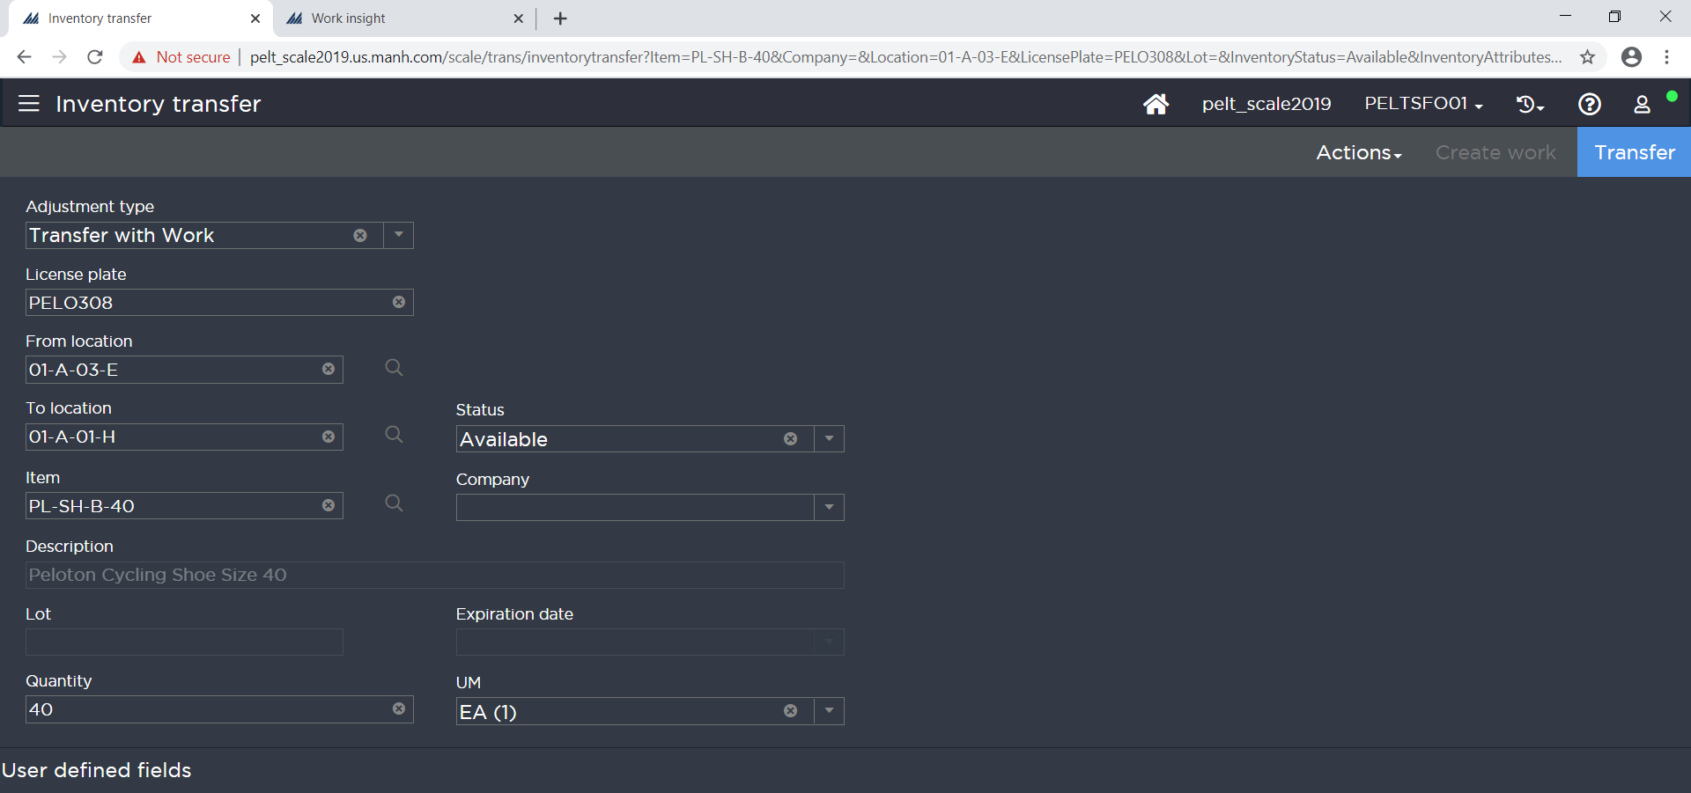
Figure: Inventory Transfer with Work

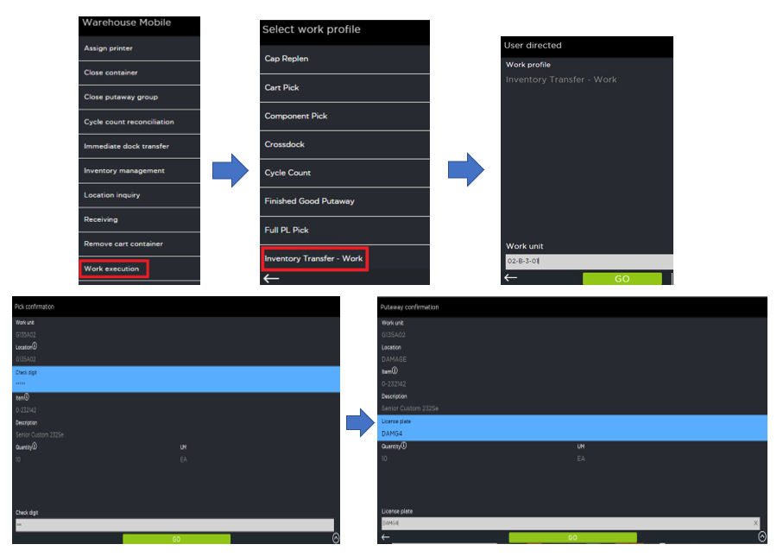
Figure: Warehouse Mobile Inventory Transfer Work Execution

Inventory Status Change

Inventory is received into SCALE with a default status of Available. However, Travis currently uses the Inventory Status value to denote the ‘Condition Code’ of inventory, which represents contrasting conditions of SKUs in the warehouse:

Condition Codes
  - A, B, C -> Available Inventory
  - G -> Unused today, but requires the inventory to be segregated if utilized in the future
  - H -> Damaged Inventory
  - L -> Litigation

Warehouse personnel will use an Inventory Status Change transaction to update inventory statuses throughout the warehouse. These status change types are configurable, and security is maintained to control which users have access to which status change types.

The Inventory Management option can be initiated blindly from the insight screen main menu. It can also be initiated by selecting a location/item combination in the Inventory Insight, in which case the location and item are automatically defaulted. The user then specifies the new inventory status. At confirmation SCALE updates the inventory status for the item and location combination. SCALE also creates a history log of the inventory transaction.

Note: A single license plate can only hold one inventory status for each item it contains. A single location cannot hold the same item with a quantity in two different statuses if the location is not License Plate tracked.

Status Change Types

  - Copied from existing SCALE 2016 environment

REPLENISHMENT

Demand Replenishment

Demand Based Replenishment is not currently utilized by Travis and will not be configured for initial Active SCALE go-live.

Capacity Replenishment

Item Location Capacity based replenishment is used by Travis daily and is configured to run for both PL and CS increments. Capacity Based replenishment will be run on a scheduled job as currently defined for SCALE 2016 or may be manually invoked by a user as needed and will leverage the configured Item Location Capacity records (minimum replenishment threshold %) to determine what locations within the warehouse need to be replenished.

Note: The Minimum Replenishment Threshold value for each location will be dictated by the Location Type:

  - Location Type – 48x48x50
    - 0% Threshold
  - Location Type – 48x48x62
    - Set to replenish at the qty of one tier of CS/maximum qty for the location type

Replenishment Allocation Zones

 | Allocation Zone | Description
1 | Mirror existing SCALE 2016 replenishment allocation location selections | - Based on existing configurations in SCALE 2016

Replenishment Allocation Sequence(s):

  - Will be copied over from existing SCALE 2016 environment.

Work Creation Replenishment

The replenishment work creation process is like the work creation process performed during the locating portion of the receiving process. After performing replenishment, SCALE creates a Work Unit to pick the inventory from its reserve location and transport it to its active location. Based on the configuration in the Work Group, Work Type, Work Criteria, and Work Creation Master, the system analyzes, sorts, and bundles the replenishment requests to create a Work Unit. This Work Unit may consist of multiple items from many different locations.

Replenishment Work

Replenishment work is performed within SCALE as System Directed work. Users sign onto a RF Device and choose the Warehouse Mobile Work Execution option. Users then choose the Replenishment work profile. The user is then prompted to scan a location for SCALE to assign a Work Unit in closest proximity (or highest priority if desired). The user is assigned a Work Unit and SCALE then presents the user with the first pick which displays the location, item, and quantity to be picked. Users are required to verify the pick by scanning the location check digit and then hitting the ‘OK’ button. Once all the picks have been completed (all picks can be any number of items – this is defined by Travis Association for the Blind), the user confirms the putaway to forward active location(s) by scanning the active location check digit. After this, the user can be assigned the next Work Unit.

Note: Travis currently utilizes the ‘Allow renaming of existing work unit’ option to assign a temporary replenishment LPN to facilitate replenishment work within the facility. Temporary LPN is a next up label supplied by Travis.

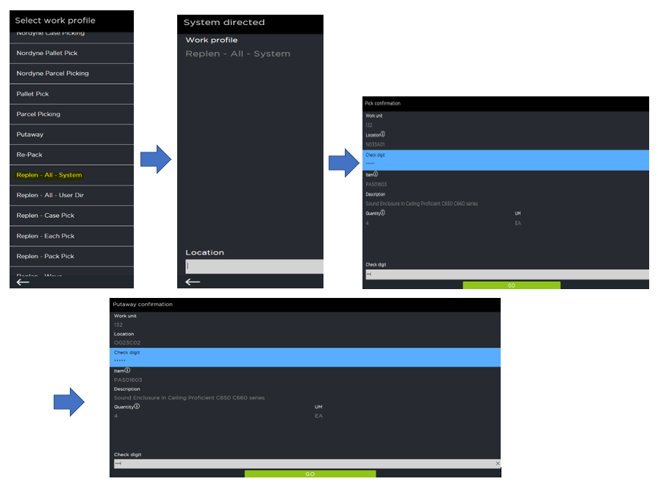
Figure: Warehouse Mobile Replenishment Work Execution

CYCLE COUNT

Generating Cycle Counts

Planned Based Cycle Counting

SCALE utilizes Cycle Count Plans for everyday cycle counting. Travis Association for the Blind personnel can define the Cycle Count Plans in configurations ahead of time, or on the fly from Cycle Count Plan Insight. A Cycle Count Plan is used to define a range of items and/or locations for which to generate cycle count work. For an example of location criteria, Travis Association for the Blind can exclude a location which has been flagged as inactive/frozen. For an example of item criteria, Travis Association for the Blind can use item attributes such as Item Department, Item Class, etc. Once the plan has been created, SCALE creates work to count a specified number of locations within the criteria of the Cycle Count Plan. Each location determined for cycle count is generated as a separate work unit in SCALE.

The Cycle Counting requirements for Travis are already configured in the existing SCALE 2016 environment and will be copied over during the DB upgrade.

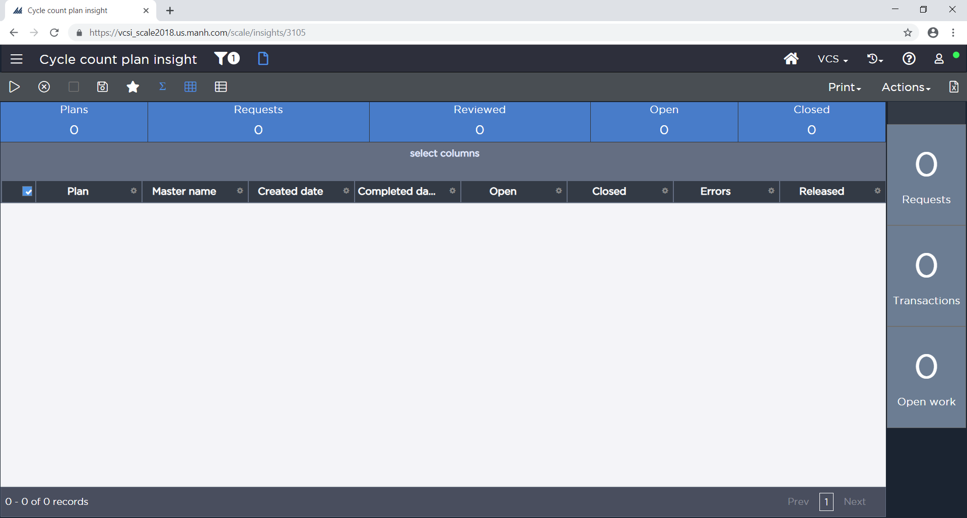
Figure: Cycle Count Plan Insight

Activity Based Cycle Counting

Activity-based cycle counting is the concept of triggering a cycle count request after a warehouse activity (i.e. short picking). The triggering of these requests is tied to the location being processed. After the transaction is executed, the location is reviewed to see if cycle count work should be generated. SCALE can create cycle count work for a location for instances such as short picking a location, driving the inventory for a location below a certain threshold, for example 0 quantity (empty), or time since last count.

For Travis Association for the Blind the below activity counts will be created:

- Verify Empty
  - Interleaved to existing Work Profiles

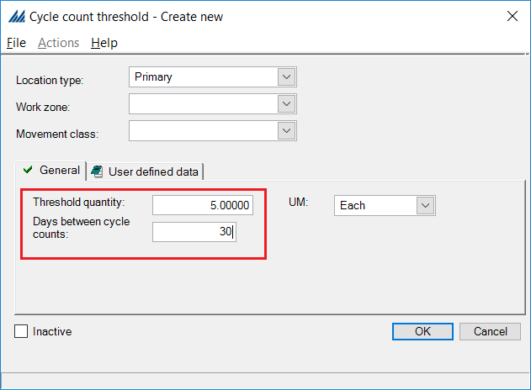
Figure: Cycle Count Threshold config window

Performing Cycle Counts

Work Execution

To confirm the cycle count, users sign onto an RF Device and open the Warehouse Mobile Main Menu, choose the Work option, and then specify the Cycle Count Work Profile. Users are then directed to verify the quantity of a specific item in a location. If an item is found in the location that SCALE does not know is there, the user can select the ‘Add’ option and enter the item and quantity for the inventory. The system is configurable to display the system quantity field or not depending on several different criteria, including Work Type, Username, and Work Zone.
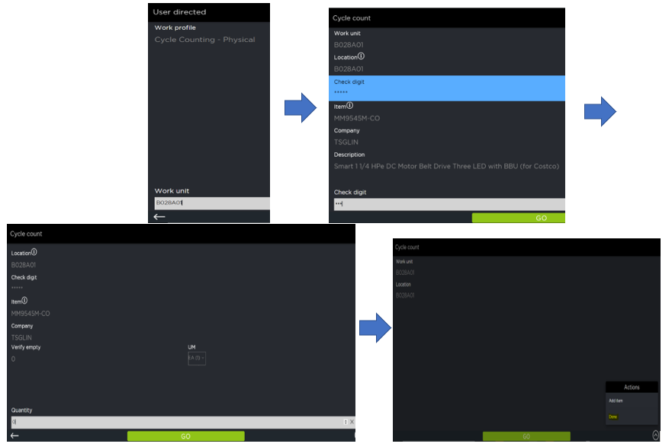
Figure: Warehouse Mobile Cycle Count Work Execution
Note: Cycle Count Preferences are set up to “Verify Bad Count”. Cycle count work execution is set to Standard with the System Quantity hidden from the user.

Upon entering the information, SCALE determines whether to post the inventory adjustment or update the cycle count request to status Pending Review. SCALE makes this determination based on the user’s cycle count tolerance of either quantity or cost of the pending adjustment. Travis Association for the Blind tolerances will be cost based. If the inventory adjustment falls outside of the user’s tolerance, then a supervisor must review the count before SCALE posts the adjustment to the inventory. If the adjustment falls within the tolerance, then SCALE updates the inventory in the location and creates an Inventory Adjustment transaction to record the change in inventory.

Note: Cycle Count Tolerances will be set to $XXX for Travis Association for the Blind to begin the implementation.

Cycle Count Reconciliation

For cycle count transactions that fall outside of a user’s tolerance, SCALE updates the status of the Cycle Count work to Pending Review.

To reconcile a cycle count, a supervisor can use either the Reconcile option from the Cycle Count Request Insight screen or the Cycle Count Reconcile option from an RF Device. From the Cycle Count Request Insight, the supervisor selects the appropriate cycle count in status Pending Review. On each of the counts requiring review, the supervisor uses the Reconcile action to complete the cycle count adjustment. Once in the reconcile screen, the supervisor enters the correct On-Hand quantity for the specific item in the location.

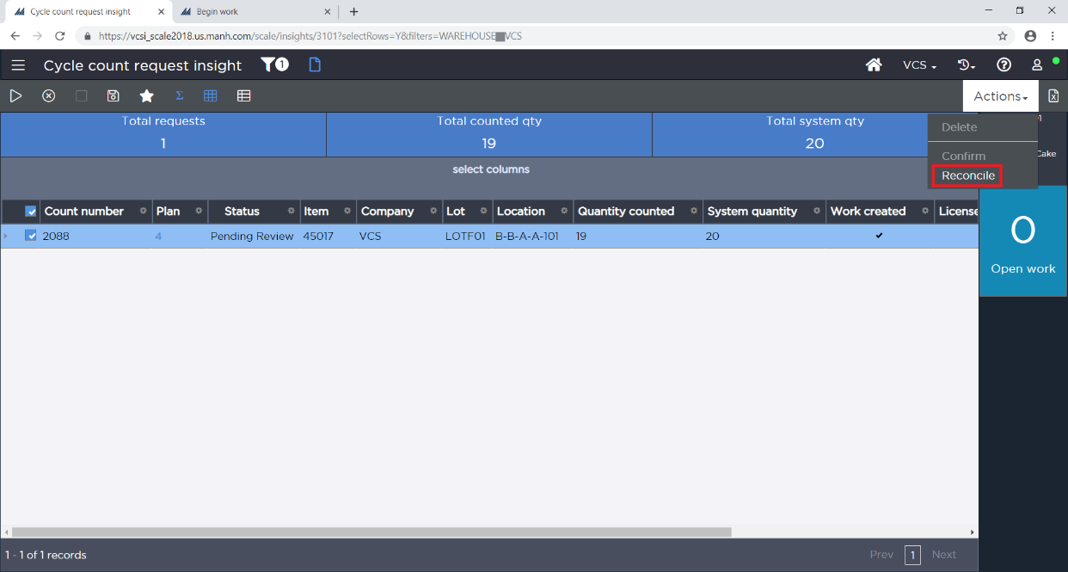
Figure: Cycle Count Reconcile Using Insight Screen
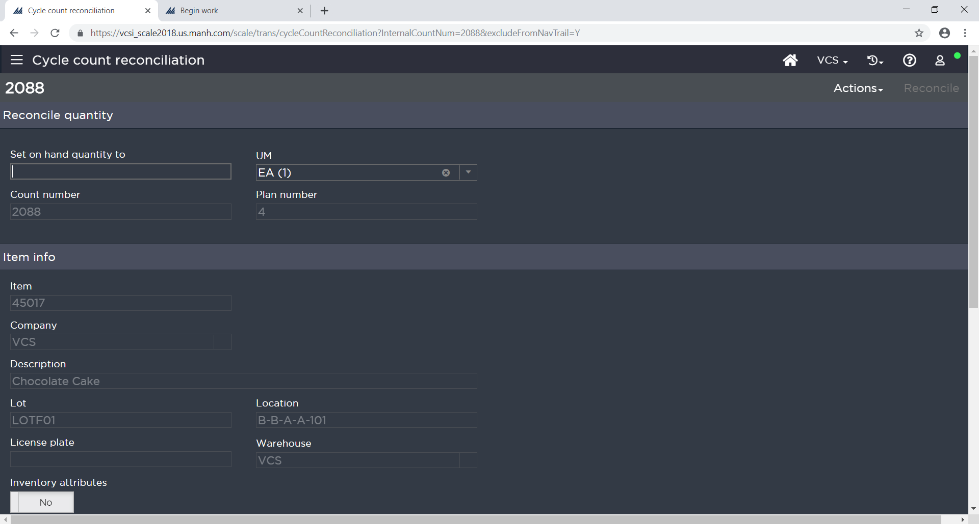
Figure: Cycle Count Reconciliation Insight Screen
From an RF Device, the supervisor selects the Cycle Count Reconcile option on the Warehouse Mobile page. The supervisor is then directed to verify the quantity for a given location.

The supervisor performs the count and if the count is same as the system quantity, the supervisor enters the quantity and closes the process. If the supervisor performs the count and the count is different than the system quantity, SCALE will ask the user to verify their count once more before submitting the required inventory adjustment (defined on Cycle Count System Values configuration) to correct the on-hand quantity to the value the supervisor has counted in the reconciliation process.

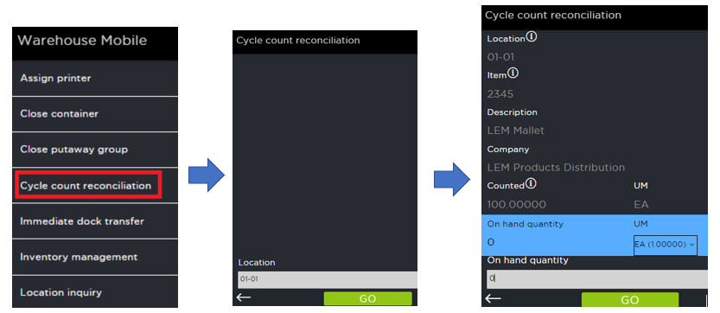
Figure: Cycle Count Reconcile through Warehouse Mobile

OUTBOUND

WAVE PROCESSING

Outbound shipments (Parcel and LTL) are sent to SCALE via the host system. On a scheduled basis, these shipments are interfaced into SCALE. Any shipments that fail validation are written to an output folder for further review. Once corrected, the shipment(s) can be reprocessed during the next scheduled interface download (or the interface can be manually invoked).

Note: Travis will utilize XML file-based interfaces for shipment download processing

In the 2016 environment all shipments are sent to SCALE with a carrier of UPS and after the download process is complete, a user will manually update shipments to LTL based on the weight/volume of the order. In Active SCALE, the assignment of LTL will be accomplished via Boomi during the download process. Users may still manually update the carrier for additional shipments to LTL as required from the Planned Shipment Insight/Shipment Screens as needed.

Once successfully downloaded, the shipments are viewable as SCALE shipments in the Pool in Planned Shipment Insight. The shipments can be viewed by Carrier, Carrier Service, Order Type, Priority and Scheduled Ship Date (Travis may create Planned Shipment filter criteria records to view shipments in pool by other criteria of their choice).

Note: Pool Views are utilized heavily at Travis in the 2016 environment and time should be allocated in the Build Phase for replicating the existing Pool Views as Planned Shipment Filters.

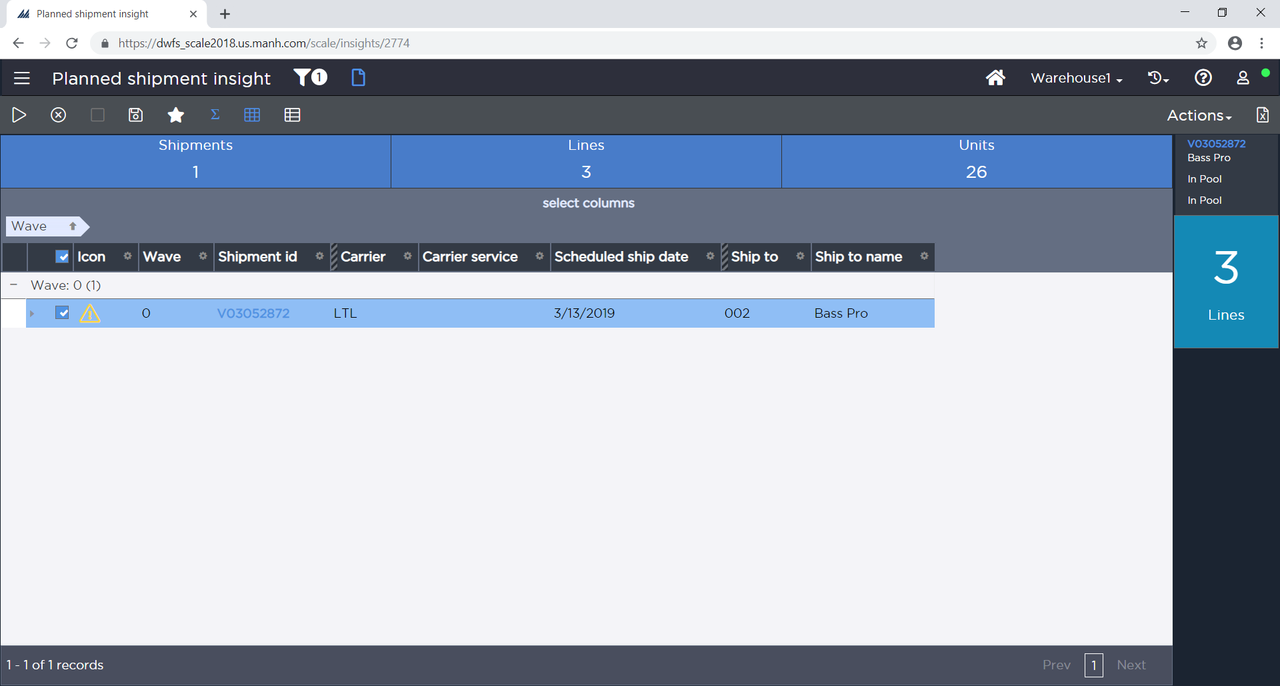
Figure: Planned Shipment Insight
All shipments are processed through the system in a wave. A wave consists of a series of wave steps. Each wave step controls a function of the wave.
Wave Flow:

Sequence below indicates the order in which a wave step will be executed as part of the wave process.

Sequence | Standard Wave Flow Description
10 | Start Wave
1000 | Complete Wave
Standard Wave Flow

Sequence | Multi-Pack Wave Flow Description
10 | Start Wave
1000 | Complete Wave
Multi-Pack Wave Flow

Note: Existing Wave Flows from 2016 environment will be copied over for use with Active SCALE.

After shipments are downloaded to SCALE and sorted in Planned Shipment Insight, they will first be added to waves using the ‘Multi-Pack’ Wave Master. The Multi-Pack Wave Master is used to handle initial Shipment Consolidation and update of the Shipment Detail Packing Class which will ultimately be used in subsequent waving.

Add to Wave

To initiate the wave process, the wave planner selects a shipment (or multi-selects more than one shipment) from the Planned Shipment Insight and selects “Add to Wave” from the Actions menu. Next, the wave planner is prompted to add the shipment(s) selected to an existing open wave, or they may select New Wave to manually assign the shipment(s) to a new wave. When executing the “New Wave” action, the system prompts the user to select a “Wave Master” to act as a template that manages the movement of shipments through the wave cycle. The Wave Master defines the Wave Flow, Replenishment Master(s), and Paperwork/Label Master to use for the wave. The Wave Flow defines the sequence and specific steps SCALE performs when running a wave. Examples of Wave Flow steps include allocation, work creation, printing documents, etc. The Wave Flows are defined via the Wave Flow Configuration. The Replenishment Master defines what replenishment masters are eligible to evaluate demand within the wave. The paperwork/label masters define the documentation that is printed with a given wave.
After confirming the “Wave Master” for a wave, the system assigns a wave number (via a next up counter) to group the selected shipments. The shipments are removed from the pool (Planned Shipment Insight) and the wave is created in Wave Insight. The wave has a unique wave number and the wave name as specified when creating the wave. The wave is now ready to be run.
For Travis, following batches have been identified:

- Parcel
  - Parcel – most common UPS wave type
  - Parcel Tomorrow - will change all carrier service level to UPS Next Day Air on all orders
  - International Parcel – will print labels in order of shipment (and not location) and verify all required data, such as phone numbers and postal codes, are on all orders.
- LTL
  - LTL – Most commonly used wave type. If any order is non-UPS carrier, all orders in the wave will be changed to show an LTL-Generic carrier

Note: Within the above groups, Travis will create many different subgroups for waving based on priority, ship to destination, customer, etc. which will mirror the standard waves created in the 2016 system today. Examples provided above.

Run Wave

After reviewing a wave and making any necessary changes, the wave planner uses the Run Wave action on the desired wave in the Active Wave view of the Wave Insight. Upon confirmation of the run wave request, the system executes the steps detailed in the Wave Flow associated with the wave. Upon completion of running the wave, the system moves the wave into the Completed status.

Wave Steps

The following sections explain the logic the system uses when executing the various steps that are included in the wave flow.

Start Wave

Start Wave is required for all wave flows and marks each shipment with a status of In Wave.

Override Data: Set Status Flow

This Override Data Wave Step updates the Status Flow field of the Shipment Details based on Carrier Type.

Parcel Status Flow
Status | Status Name
100 | In Pool
200 | Wave Pending
201 | In Wave
300 | Picking Pending
301 | In Picking
400 | Packing Pending
401 | In Packing
700 | Ship Confirm Pending
800 | Load Confirm Pending
900 | Closed
LTL Status Flow
Status | Status Name
100 | In Pool
200 | Wave Pending
201 | In Wave
300 | Picking Pending
301 | In Picking
400 | Packing Pending
401 | In Packing
650 | Loading Pending
700 | Ship Confirm Pending
800 | Load Confirm Pending
900 | Closed

Dock Management Flow

A dock management flow record includes information which determines how the system will assign a dock location destination to a shipment line/container, and if the line/container is eligible for assignment. Each flow record is made up of a series of detail records that identify what selection and assignment strategies that the system should use when a quantity hits a certain status in your status flow. You can indicate what type of dock location you want the system to assign to this entity. Also, both the flow header and detail(s) have a default location that the system will assign as a "fallback" option in case no eligible dock area/positions are found.

Note: Existing Dock Management Flow records will be copied over from the 2016 environment as part of the conversion process.

Override Data: Set Packing Class

This wave step will be utilized for all orders as part of the initial waving under the ‘Multi-Pack’ Wave Master. As part of this wave step, SCALE will assign a Packing Class value on the shipment detail record which will indicate what items can be packed together in a single shipping container. This value will also link to a Container Group which will define what size boxes should be considered eligible to use when packing a given item.

Note: Waves processed on the Pack Size MHE system utilize different Container Types than are configured in SCALE in the 2016 environment. As part of the conversion to Active SCALE, the existing integration with Pack Size will be enhanced to include two-way communication (adding Pack Size to SCALE direction) so that Pack Size can pass back the actual Container Type used to update the Shipping Container table in SCALE.

Rule Assignment

Rule Assignment wave step assigns each Shipment Detail with an allocation rule to be used in the Allocation wave step. This assignment is configurable based on Shipment Header and Detail fields.

Allocation

SCALE allocates inventory towards a shipment by using the allocation rule defined on the shipment detail. Allocation rules define what locations and units of measure are eligible for allocation and how SCALE should allocate that inventory. For example, an allocation rule can be configured to allocate inventory only from mid-level bins and to allocate the inventory with the closest expiration date (FEFO). Allocation rules can have multiple sequences. SCALE attempts to allocate inventory using the first sequence and if inventory could not be 100% allocated, SCALE continues to the next allocation rule sequence to attempt to allocate the remaining inventory.

Allocation rules are set on the shipment detail in one of three ways. The allocation rule can be set at the item level (in the Item Master configuration) which in turn automatically defaults on the shipment detail. The interface can also set the allocation rule on the shipment detail. Lastly, the allocation rule can be determined in the wave just prior to allocation occurring. This is done using the Allocation Rule Assignment functionality. Allocation Rule Assignment sets the allocation rule on the shipment detail based on user-defined criteria. For example, based on the customer and order type, the allocation rule can be set to one that allocates in only full cases. If no allocation rule is set on the shipment detail, the *Default allocation rule is used. To allow for maximum flexibility and easy addition of new items and allocation rules, the allocation rule is assigned on the Shipment Detail using the Allocation Rule Assignment functionality in the wave. Travis may still manually set the allocation rule in the interface or via the Shipment Detail screen as needed.

Allocation Zone Definitions
 | Allocating Zone
1 | A – Floor (F)
2 | A – Shelf (S)
3 | A – Mezzanine (M)
4 | A – Rack (R)
5 | A – TBD

Allocation Sequence – Parcel:

Seq | Strategy | Location Selection | Eligible UMs | Inventory Status | Clear Loc? | Lot
10 | First In, First Out (FIFO) | A - Floor | EA/CS | Available | N | Any lot (multiple ok)
20 | First In, First, Out (FIFO) | A - Shelf | EA/CS | Available | N | Any lot (multiple ok)
30 | First In, First Out (FIFO) | A - Mezzanine | EA/CS | Available | N | Any lot (multiple ok)

Allocation Sequence – LTL:

Seq | Strategy | Location Selection | Eligible UMs | Inventory Status | Clear Loc? | Lot
10 | First In, First Out (FIFO) | A - Floor | EA/CS | Available | N | Any lot (multiple ok)
20 | First In, First, Out (FIFO) | A - Shelf | EA/CS | Available | N | Any lot (multiple ok)
30 | First In, First Out (FIFO) | A - Rack | CS/PL | Available | N | Any lot (multiple ok)
Note: All existing allocation rules in the 2016 environment will be brought over during the conversion to Active SCALE.

Allocate Complete

By setting the ‘Allocate Complete’ flag on the shipment header, SCALE does not perform any allocation for this shipment unless the shipment can be 100% allocated. For Travis, the Allocate Complete flag is set to yes for all orders on initial waving. This flag will then be further manipulated manually by the warehouse associates if required to ship an order which can only be partially allocated.

Allocation Rejections

If the ‘Allocate Complete’ flag is not set, any quantities of the detail that fail allocation for a shipment are returned to the pool. If the entire shipment is rejected, then entire shipment goes back to pool. Rejected shipments have a yellow icon (caution symbol) and can be grouped by these icons in the Planned Shipment Insight, which indicates that they have been rejected. These shipments can be reviewed to determine the rejected lines and quantities and re-waved as desired.

Note: Default status when shipment is rejected is set to In Pool.

Container Creation

Container creation is the process in which SCALE determines the number of containers and each container’s contents for specified shipments in each wave. A unique container number, commonly referred to as a UCC 128, is assigned to every container as it is created.

SCALE first takes all items whose allocated unit of measure is set up as a ‘shippable unit’ and creates full containers. Shippable units are defined in the item unit of measure configuration. Full containers are containers that are shippable without repacking into another container (Treat as Loose = N for the UM). Pallets, gaylords, and certain cases are generally configured as shippable units.

SCALE then takes the remaining ‘loose’ items whose allocated unit of measure is set up as ‘not shippable’ and groups them together by Packing Class. A Packing Class is defined on the Item Master and then defaulted on the Shipment Detail or assigned dynamically with an ODWS in the wave. Each Packing Class is associated with a container group. A container group is a listing of container types (box sizes) listed from largest container to smallest container. SCALE attempts to cube items into the least number of containers possible. The total weight and volume are calculated for all the items on the shipment with the same packing group. SCALE first tries to cube into the first container of the container group. If capacity still exists, the system tries cubing into the next container type and continues until either capacity in the next priority is reached or there are no additional priorities.

If there is not enough capacity in the largest container, then SCALE cubes as much as possible into the largest container, calculates the remaining weight and volume, and starts over. SCALE considers the critical dimensions of each item as it creates containers. An item is not cubed into a container if any one of its critical dimensions is greater than the corresponding container dimension.

Note: If an item doesn’t have unit of measure record defined, then SCALE treats the item as having dimensions of 0X0X0 and of weight 0 LB.

Load Building

Shipments with a carrier are assigned to a shipping load during the wave based on carrier, route, and scheduled ship date. This wave step alleviates the need for personnel to manually assign the shipment to a shipping load via the Shipment Insight after the wave has run.

Note: This would represent a change from the existing 2016 Wave Flow which does not leverage wave-based Load Building.

Work Creation - Picking

The work creation process performed during the wave is like the work creation process performed during the locating portion of the receiving process. After performing allocation and container creation, SCALE creates a work unit to pick the inventory from a location and transport the inventory to the shipping area based on the configuration in the Work Group, Work Type, Work Criteria, and Work Creation Master. Each location will be assigned a numeric value called Picking Sequence that will be used to sort the picks in an order other than alphabetical by location.

Work Creation Shipping Container

Work Type: Full PL Picking

One work unit is created per pallet to be picked. For the entire work unit, the work instruction (picks) is ordered by pick sequence.

Work Type: CS Pick

One work unit is created per case to be picked. For the entire work unit, the work instruction (picks) is ordered by pick sequence.

Work Type: EA Picking

One work unit is created per loose container to be picked. For the entire work unit, the work instruction (picks) is ordered by pick sequence.

Paperwork - Labels

Wave Labels - Container Contents (LBL02) will all be printed manually via the ‘Reprint Wave Labels’ action in Wave Insight for any wave being processed outside of the Pack Size MHE system. For waves processed on the Pack Size system, the labels will be applied during container creation.

Note: Shipping Labels for Parcel orders (UPS) will be printed during Close Container.

Paperwork – Documents

No documents will be printed at wave release.

Override Data: Check for No Work

This Override Data Wave Step ensures that the Work Creation configurations are correct, and every Shipment has had work created successfully, otherwise this ODWS marks the wave for failure.

Complete Wave

Complete Wave updates each shipment with a status of Picking Pending. Shipments with this status are now eligible for release.

WAVE MANAGEMENT

After building and running the wave, the wave supervisor reviews the results of the wave using the full screen Process History Insight and Work Insight options. Depending on the results, the user may perform one of two options. These options are identified in the following sections.

Cancel Wave

If the results of the entire wave are not satisfactory users may cancel the wave using the Cancel action in the Completed Wave window of the Wave Insight.

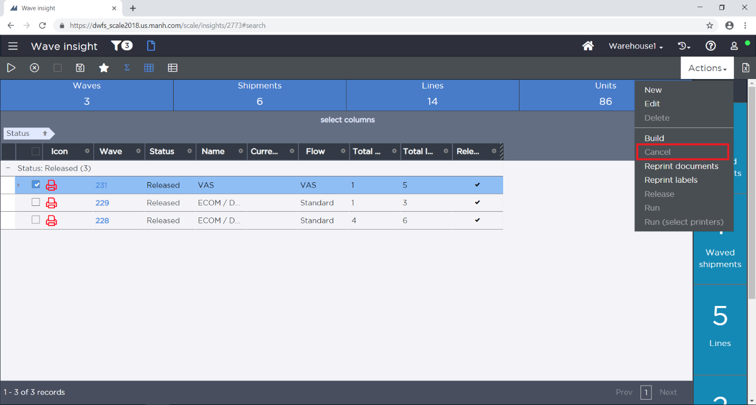
Figure: Wave Insight – Cancel Wave Option
The cancel process backs out allocation and deletes work instructions as well as shipping containers. As allocations are backed out, the corresponding inventory is now available for order fulfillment again. At the point of cancellation, Travis personnel can move the cancelled shipments onto another wave or move them completely back to the Pool.

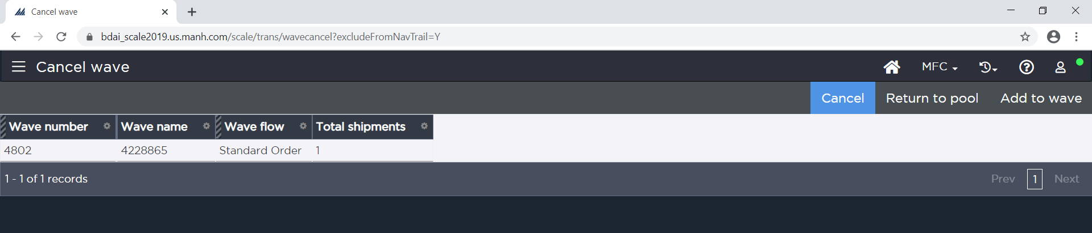
Figure: Wave Insight – Cancel Wave Option

Release Wave

If the results of the wave are satisfactory, the wave supervisor Releases the wave. The Release action performs multiple operations:

- Releases the generated work to the warehouse floor by removing the Hold Code from the work units – this allows the work to now be eligible for picking
- Prints Wave Labels and Wave Documents
  - Can be configured to print at Wave run as well, but this option is less common

Note: For Travis label printing will either be performed manually via ‘Reprint Wave Labels’ action or done through the Pack Size MHE system for any wave the DC chooses to process via Pack Size.

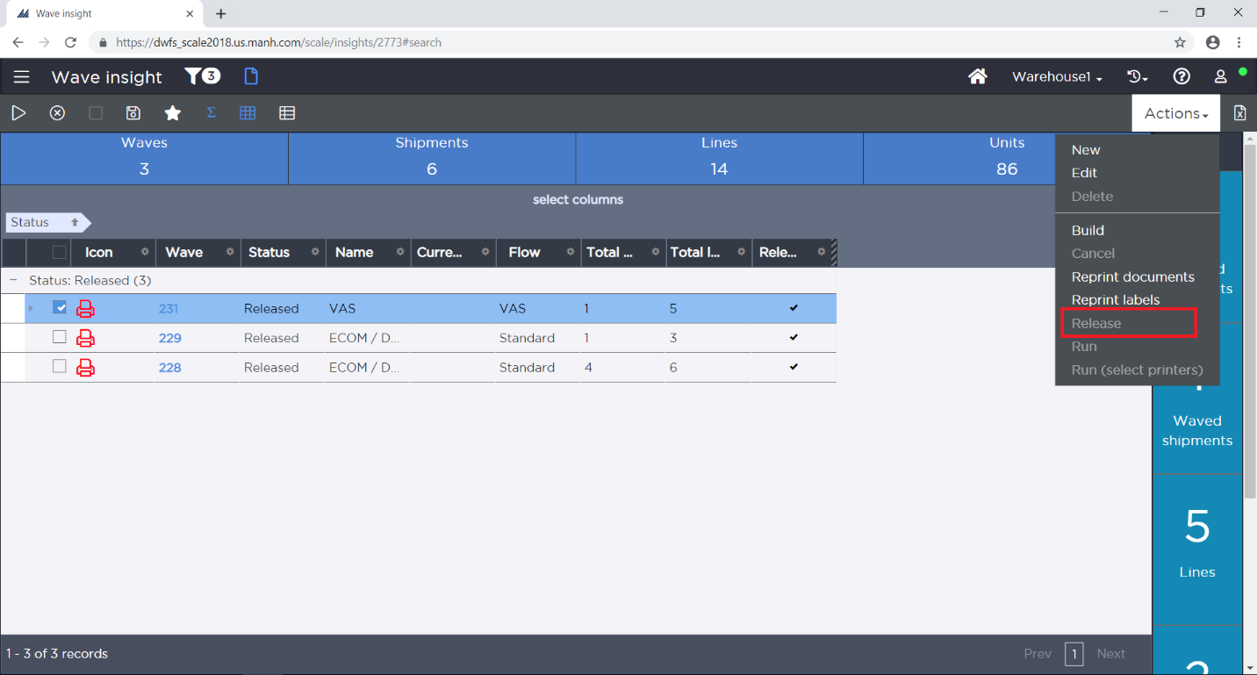
Figure: Wave Insight – Release Wave Option

Hold Codes

Hold Codes allow work to be temporarily placed on hold so that no further processing can be done against it. Work created through a wave initially has a Hold Code of “Wave Not Released”. When a wave is released, the Hold Code is removed.

Note: Hold Codes can also be manually removed or added through the Hold option from the Work Insight.

Post Wave Shipment Changes

If a change is required for an order that has been waved and released (but not picked), the shipment can be cancelled by choosing the ‘Cancel’ option from the Shipment Insight. Canceling a shipment de-allocates the inventory for the order, deletes the created shipping containers/work, and moves the shipment back into the pool. Once an order is partially or completely picked, it can be cancelled by the same process, but any items that were picked would need to be transferred back to an inventory location using the Inventory Transfer option. This can be done from Inventory Transfer Insight or Warehouse Mobile.

Note: If an order is cancelled, it cancels all the work tied to the order. Also, while trying to cancel an order, if any work related to the order is being actively executed by pickers, then order cancellation fails. Cancelling of the shipment after the wave is released can only be performed by a warehouse user. After the wave has been released, host will not be able to cancel the order (The only time host system can make changes to a shipment is when the shipment is in ‘In Pool’ status).

WORK MANAGEMENT

Work Viewing

Using the fixed station Work Insight options, personnel can monitor the progress of work. The Work Insight contains the ability to group work by condition: Open, In Progress, and Closed. Additionally, this option enables personnel to view the types of work that are open and in progress to determine if additional users are needed to help with receipt putaway, replenishment, picking work, etc. Personnel can inquire on the specifics of the work unit, such as the ‘from’ and ‘to’ location, item(s) and quantity being moved, Receipt/Shipment ID, user performing the work, etc.

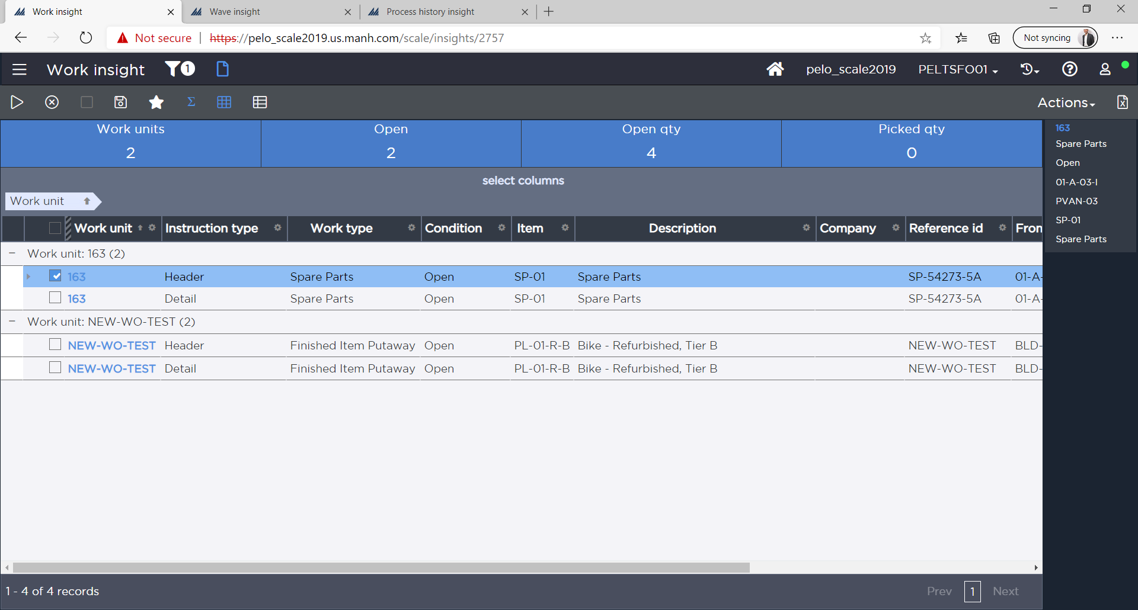
Figure: Work Insight Screen

Work Priority

SCALE allows system directed tasks to be assigned in one of two ways:

- Priority/Location/FIFO
- Location/Priority/FIFO

The above defines the sort order that system directed tasks will be assigned to users within the warehouse. Within this structure the “priority” portion from above can be critical. Most tasks will need to be created with the same priority so that they are truly processed by proximity. However, over time Travis may want to bump up the priority of certain tasks which can be accomplished through the use of the Work Priority Escalation Scheduled Job.

PICKING

For all picking at Travis, work will be executed via VoCollect. As part of the conversion to Active SCALE, Travis would like to increase the facility’s accuracy when picking items which may be stored in inconsistent quantities (IE case of 10 and case of 25). In order to accomplish this, two changes will be made to the existing 2016 workflows:

- We will add Text Message Assignment for any item that is known to be stored in mixed case quantities
  - These text messages will be defined in configurations and will be spoken to the user during VoCollect picking whenever they are picking an item which has a text message assignment configured. This message can be used to warn the user to double check the case quantity on the item prior to completing their pick.
- Add VAS assignment to any container which contains an item that comes in mixed case quantities
  - Specifics defined in Section 17.1

Using the above processes, we should be able to minimize the errors in picking these items and in turn, minimize the rework required when orders containing these items are processed through the OV Stations.

Full Pallet Picking

Assumptions:
- Containers are created in Wave.
  - Full UM Pallet Containers
- One Work Unit is created per pallet.
- Wave Labels (Container Contents Labels) will be manually printed for any full pallet pick as these would not run through the Pack Size process.
- All picking operations will be completed via VoCollect.

Travis utilizes container creation as a part of the Full Pallet Picking flow. In order to most efficiently pick the larger LTL/TL orders, Travis will create full UM pallet containers based on the quantity requested for the shipment. Any Full Pallet pick will fall under the Full Pallet Picking work type which will have one Work Unit created per pallet.

All picking work will be executed via VoCollect for Travis.

After the picks are complete, the user will confirm the putaway to the packing/OV location.

Case Picking

Assumptions:
- Containers are created in Wave
  - Full CS UMs
- One Work Unit is created per case
- Wave Labels (Container Contents Labels) will be printed manually or via Pack Size depending on how the wave is processed by the user
- All picking operations will be completed via VoCollect.

Travis will utilize container creation as a part of the Case Picking flow. For any shipment line where the item can ship alone (TAL = N), Travis would like to create one Work Unit per case for picking.

All picking work will be executed via VoCollect for Travis.

After the picks are complete, the user will confirm the putaway to the packing/OV location.

Each Picking

Assumptions:
- Containers are created in Wave for the loose items to be picked into
- One Work Unit is created per container
- Wave Labels (Container Contents Labels) will be printed manually or via Pack Size depending on how the wave is processed by the user

Travis will utilize container creation for loose item picking. Containers will be created in wave for any loose items which require packing prior to shipping (TAL = Y). One Work Unit will be created per container and all picks will be sequenced according to the configured pick sequence values on the locations.

All picking work will be executed via VoCollect for Travis.

After the picks are complete, the user will confirm the putaway to the packing/OV location.

PACKING

VAS (Value Added Services)

As part of the conversion to Active SCALE, Travis would like to incorporate VAS Assignment into the Wave Flow to help resolve an ongoing issue with items that can be stored in inconsistent case quantities (IE sometimes a case is 10 and sometimes it is 25). To attempt to catch shipping errors before the goods leave the facility, Aaron’s will provide a list of all items known to arrive in mixed case quantities and this will be used to configure VAS Assignment Criteria. The assignment criteria will assign VAS to any container created which contains an item known to come in mixed quantities and this VAS will allow the user to double check the product during the OV process.

Note: VAS can be assigned only when containers are created in Wave.

VAS functionality is managed within SCALE as shown below –

For any container that has a VAS Activity assigned, the user will start the VAS process by selecting the VAS Insight Screen from the main SCALE Menu:

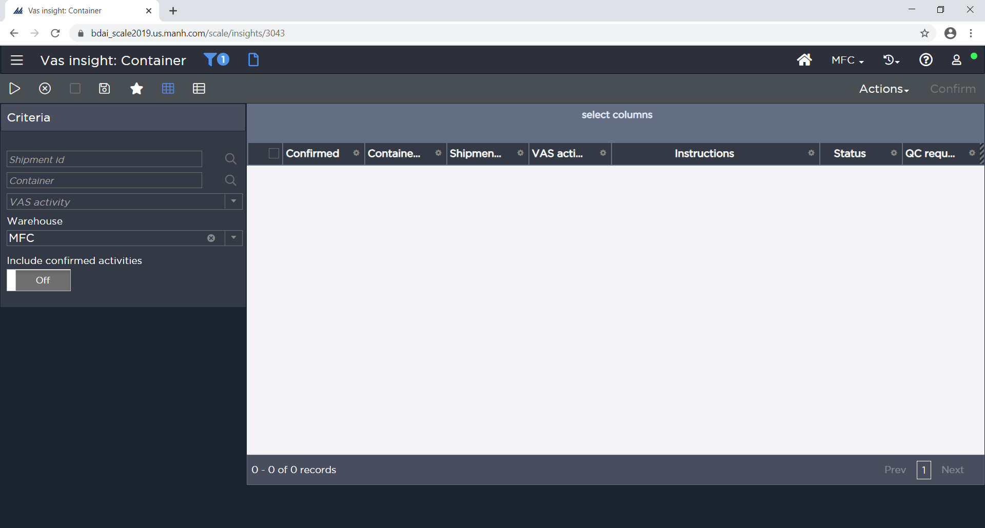
Figure: VAS Insight Screen
Next the user scans/types the Container ID of the given carton and is presented with the required VAS Activity. Once complete, the user checks the confirmed check box and clicks on the ‘Confirm’ action to indicate VAS is complete and the carton is ready to enter the packing (close carton) process flow.

QC Process (Order Verification/OV)

For Travis, all containers created during waving will be flagged for Outbound QC. Containers may also be manually flagged for outbound QC at any time via Full Screen Shipping Container Insight.

Note: QC can be assigned automatically only when containers are created in Wave.

QC Confirmation – Insight Screen

QC Assignment – Manually (Insight Screens):

If a supervisor chooses to mark a container for QC, then supervisor will scan the Container ID from container content label in the Shipping Container Insight screen and search for the container. On the container record, the user will mark the container for QC via the Actions menu. Now this container must go through the QC verification process.

QC Execution (Insight Screens):

If a container requires QC, the user scans the Container ID from the Container Content Label in the QC Workbench. Next the user scans each item (grocery style scanning). Once all items in the container are scanned, the user clicks the ‘Confirm’ button.

Note: QC execution/assignment on the RF device via Warehouse Mobile is not yet available. Currently, QC execution will need to be handled via the QC Workbench from a full screen workstation which aligns with the current procedures at Travis.

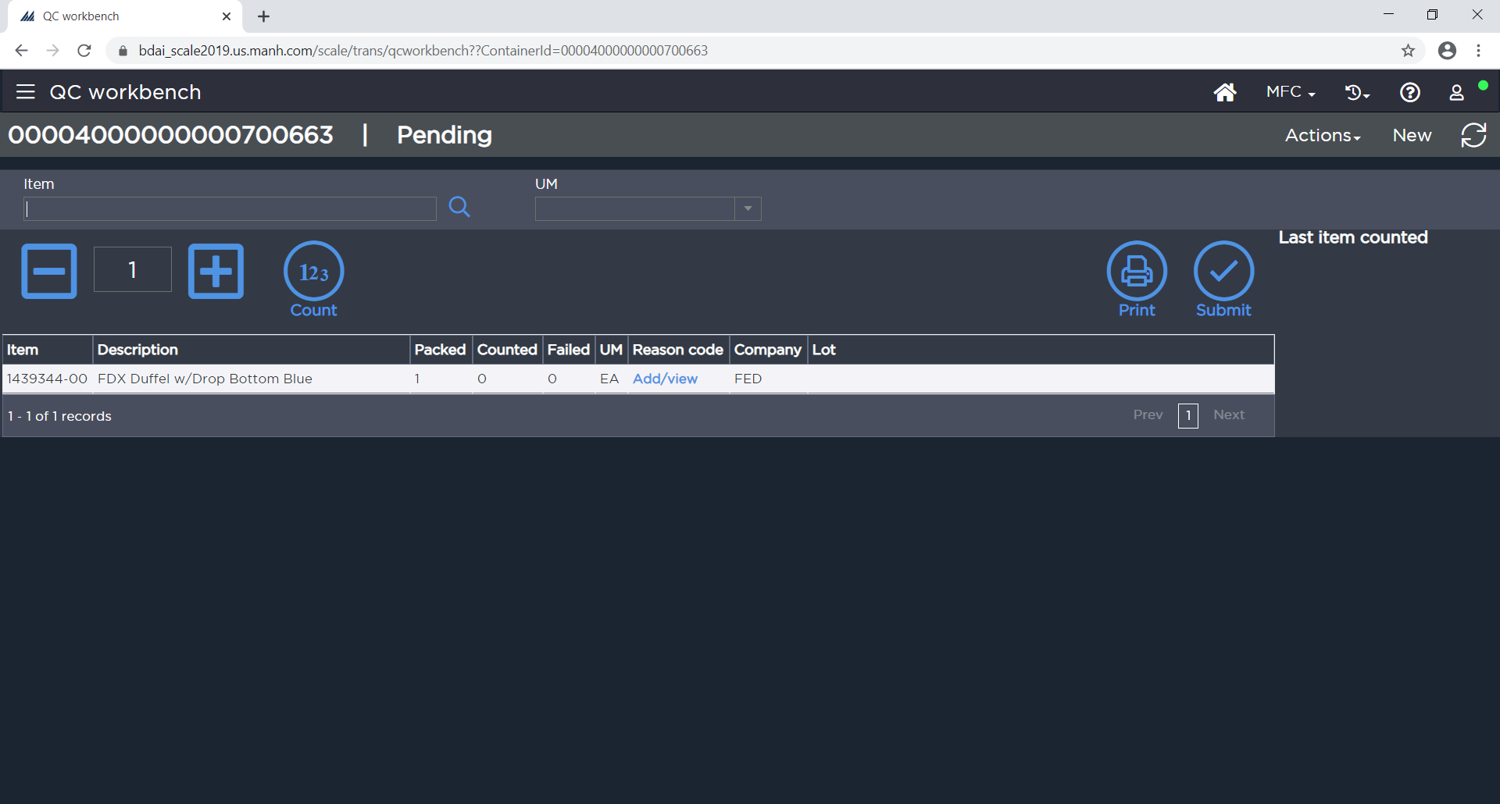
Figure: QC Workbench
If the items and quantities scanned match the system expected quantities, the user receives a message that QC was successful. If not, the user receives a message that QC failed and need to provide reason codes for any missing quantities. These reason codes are configurable by Travis to record things such as damaged item, incorrect item, etc. The user needs to correct any failures and successfully pass QC before continuing to Close Container.

Once the container passes QC, user will return the container to the normal process flow where it will be added to a MOP if it belongs to an LTL order or moved to the Dock Door for parcel orders.

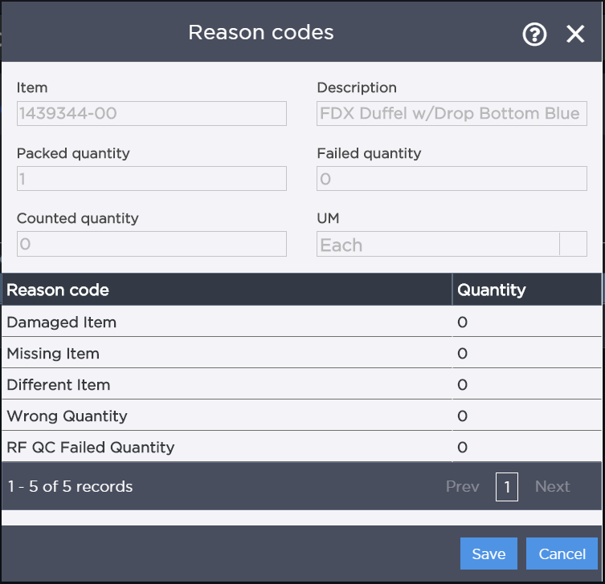
Figure: QC Reason Codes

Close Container

To advance the status on the container and to identify that the container is packed, and no other item is put into it, the user will use the close container option.

For Travis, all orders both parcel and LTL, need to have the close container option completed to advance the status of container.

Parcel
- Close Container will be performed in the Packing location after it has passed through the OV Station
- Close Container for parcel orders (UPS) will trigger the printing of the Shipping Label (LBL03)
- As each detail line is packed complete, EX-XX will be triggered and result in the printing of the 1348 Form (DOC02) configured in the Travis SSRS environment

LTL
- Close Container will be performed in the LTL flow prior to the containers being added to MOPs and transferred to the Dock Doors
- Close Container will be used to print the Vendor Labels (LBL04) for LTL/TL shipments

Close Container Operation

The user accesses the Close Container option from the Close Container Insight Screen or Warehouse Mobile to close the container. The user scans the Container ID from the Container Contents Label. The screen will update with the shipment and container information. If necessary, the user changes the container type from the dropdown. User will click on the ‘Close’ option to confirm closing of the container. If the container gets successfully closed, SCALE updates the container status to ‘Ship Confirm Pending’ (Parcel) or ‘Loading Pending’ (LTL/TL shipments) based on the custom status flow assigned at the detail level.

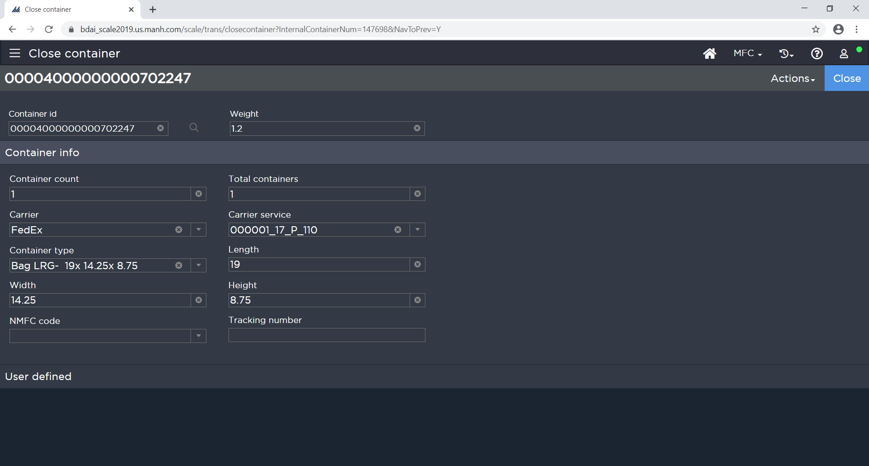
Figure: Close Container Screen

Shipping Container Insight

If necessary, Shipping Container Insight can be used to modify the contents of the Shipping Container. The user can update the quantity to pack to 0 for any items needing to be unpacked from a container. Once unpacked, the user can repack into new containers using the Packing screen.

If user doesn’t have a Container ID to scan but still must perform the close container action, then they will use the Shipping Container Insight screen and filter based on the Shipment ID. From the Container Insight, users can select the Container ID and then use the ‘Close’ Action to close the container.

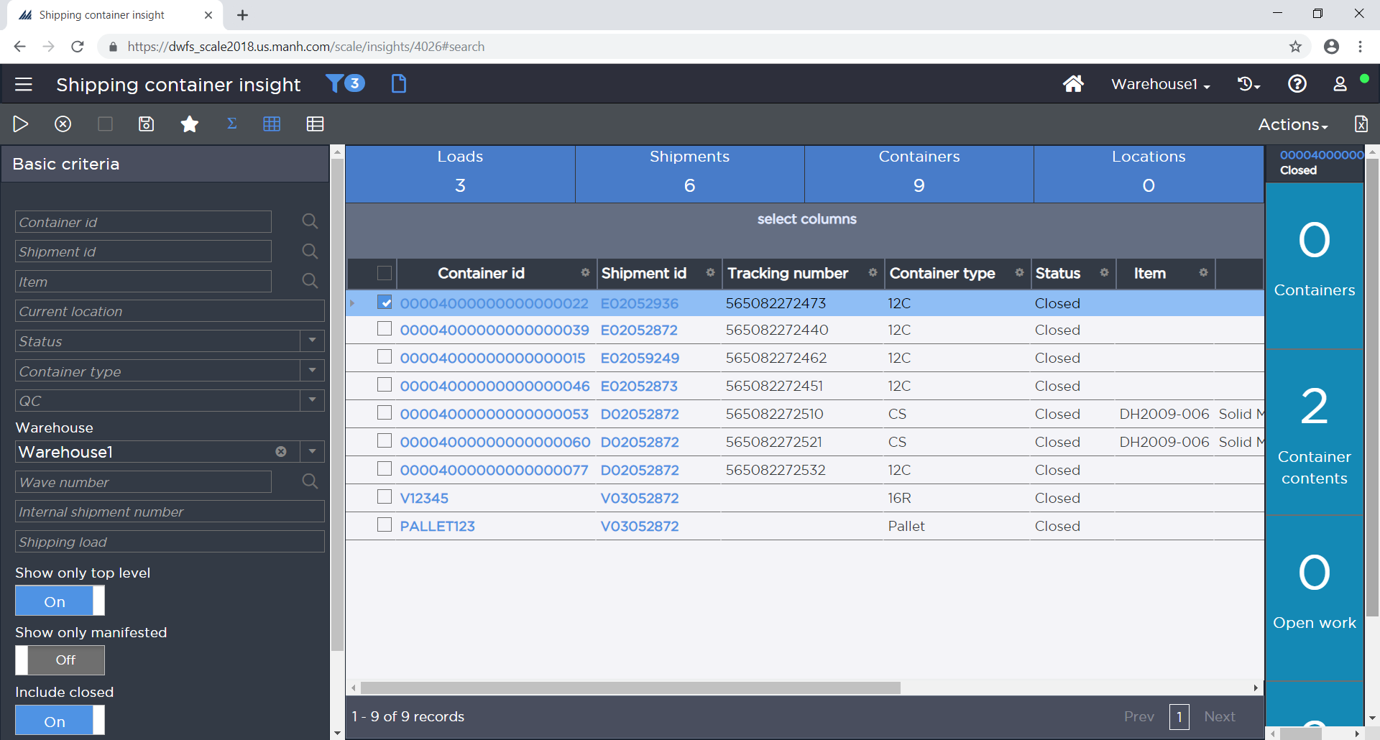
Figure: Shipping Container Insight

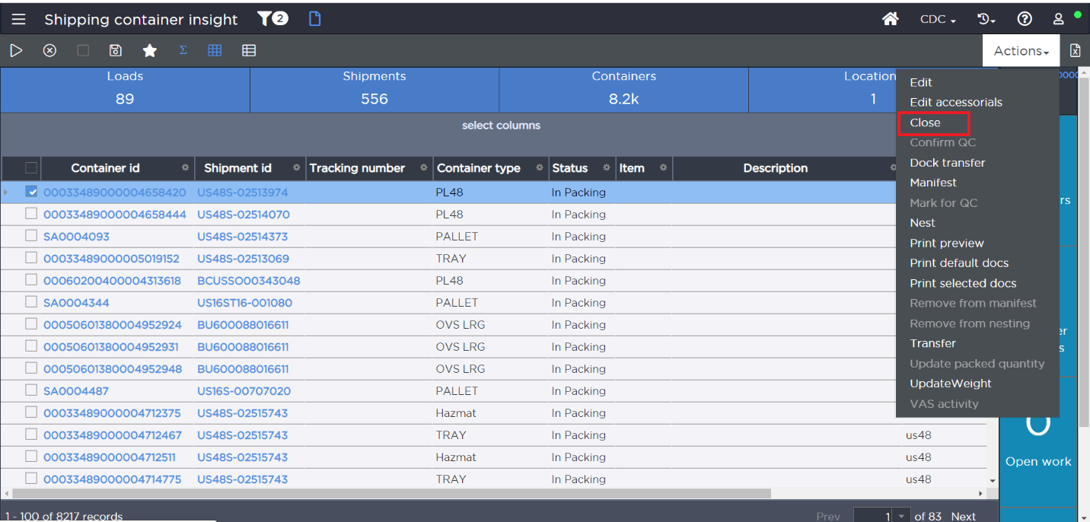
Figure: Shipping Container Insight with Close Container Option
Note: In order to edit container contents, a container must be in the Packing location.

Carrier Assignment

If there are exception scenarios and the warehouse operations team needs to change the carrier, then the user will use the Shipment Insight screen and utilize the ‘Edit’ option to change the carrier assigned.

Alternatively, if a Shipping Load already exists for the correct carrier, the ‘Transfer Shipment’ option can be used to move a shipment from one load to another. The user will be presented with an option to provide the destination shipping load. If the user knows the load number, then they can enter the shipping load number and SCALE will transfer the shipment to that load (which will update the carrier to the carrier for the destination load).

If the load is not known, then user can select to create a new load and select the carrier for the new load. SCALE will create the new load and then transfer the shipment to the new load.

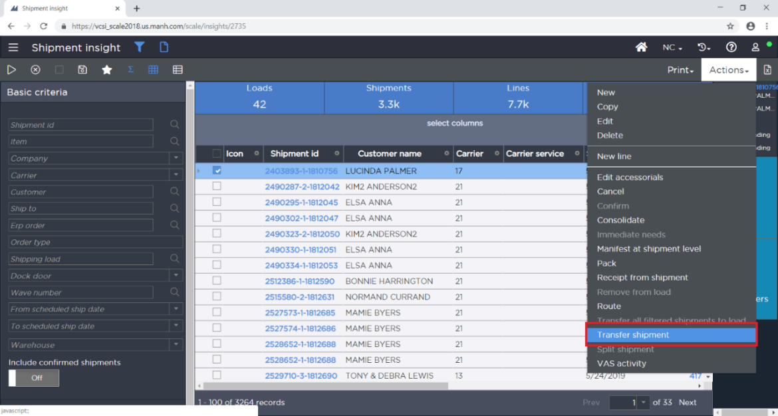
Figure: Shipment Insight – Transfer Shipment Option
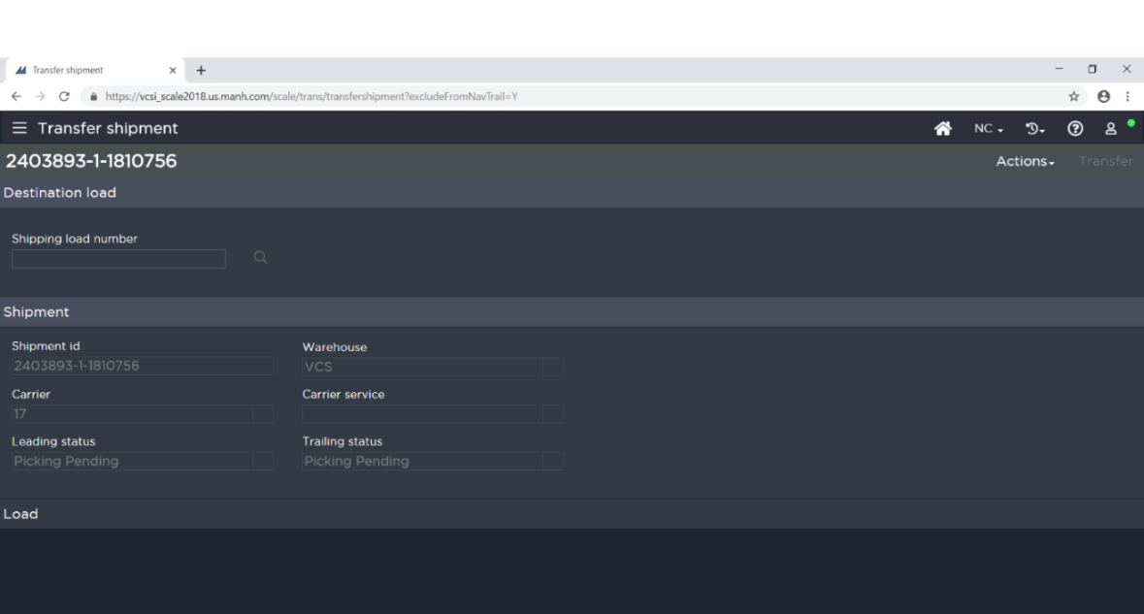
Figure: Transfer Shipment Option – Enter Destination Load Number
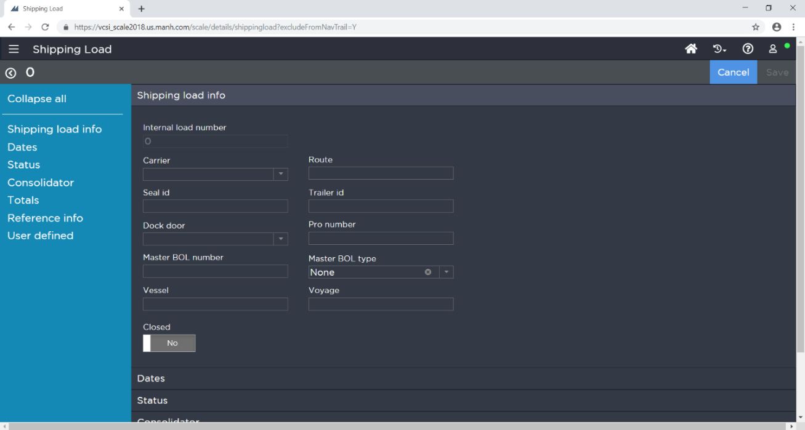
Figure: Transfer Shipment Option – Create a New Load

DOCK MANAGEMENT

Dock Management will be a primarily manual task at Travis.

Load Creation

Travis will utilize load building as part of waving. SCALE will create shipping loads in the wave based on the below criteria:

- Scheduled Ship Date
- Carrier
- Route

This means that for a given wave, SCALE will likely create multiple shipping loads for the various carriers assigned to the shipments on the wave.

Note: Various service levels are not broken into separate loads unless they are entered in SCALE as unique carriers. IE – UPS Ground and UPS Express would build to the same Shipping Load in SCALE provided the carrier in both cases is ‘UPS’ and the service level is separated into the Carrier Service field in SCALE.

Dock Door/Staging Lane Assignment

Travis will manage Dock Door and Staging Lane assignment in the following fashion:

- Manual
  - Users will make the dock door/staging lane decision manually via the Immediate Dock Transfer (IDT) process.

LOAD CONFIRMATION

Processing

Personnel use the Shipping Load Insight or Shipment Insight options to monitor the status of shipments and loads. Once all shipments for a Load are in Ship Confirm Pending status, the Load can be confirmed. To Confirm the Load, a user selects the Load and uses the ‘Confirm’ action in Shipping Load Insight.

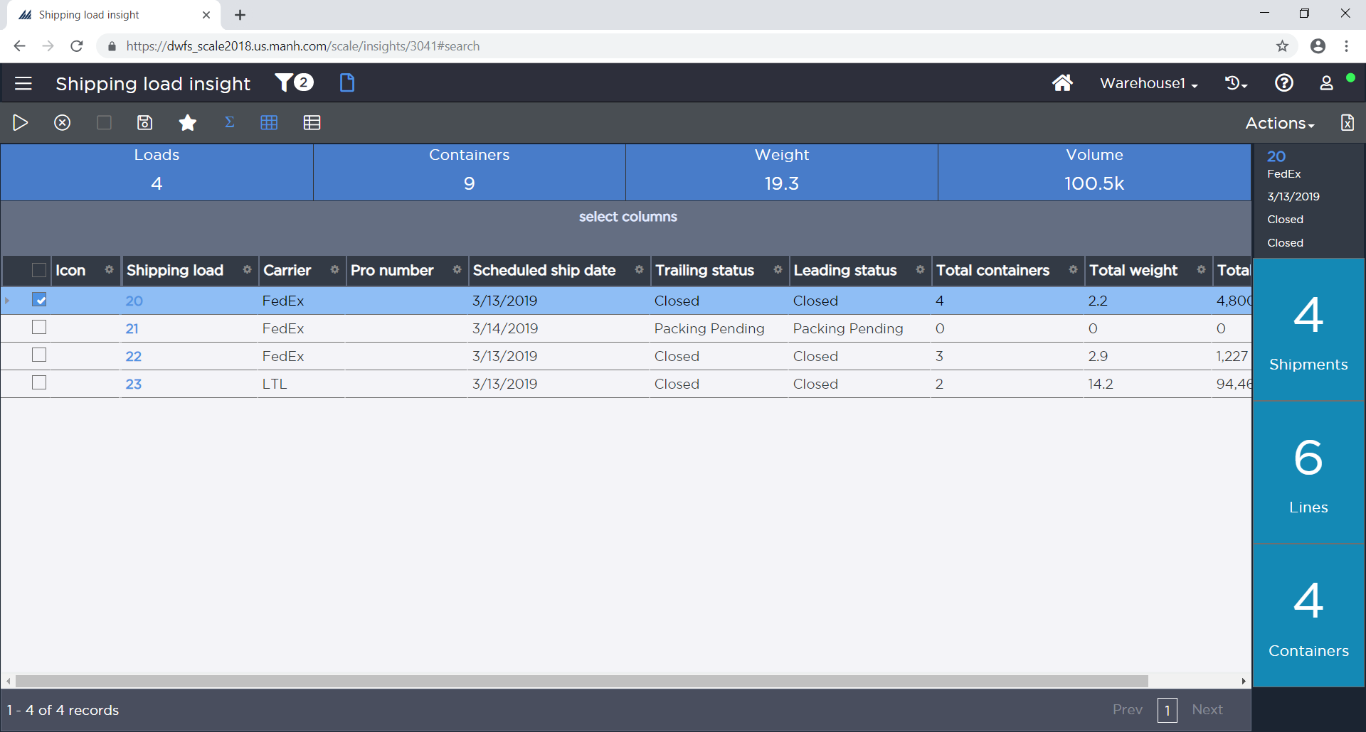
Figure: Shipping Load Insight
Once a load has been confirmed, all statuses (load, shipments, details, containers) are moved to Closed and inventory is relieved from the Shipping Dock (is officially out of the building).

Bill of Lading (DOC03) can be manually printed for all shipments on a given Load as part of the Load Confirmation process. This document can also be printed manually at any time from Shipment Insight/Shipping Load Insight.

PARCEL MANIFESTING PROCESSING

All parcel manifest processing is executed from the Manifest Insight screen. Users can view any pertinent manifest information from this screen. FedEx is excluded from this screen as there is no end of day processing necessary for FedEx since the manifest data is automatically transmitted every two hours.

End of Day Processing

Manifests can be closed at the end of the day by clicking on a Manifest from the Manifest Insight and choosing the Close option. Rating Systems Value “Allow Multiple Manifests per Day” is set to Yes.

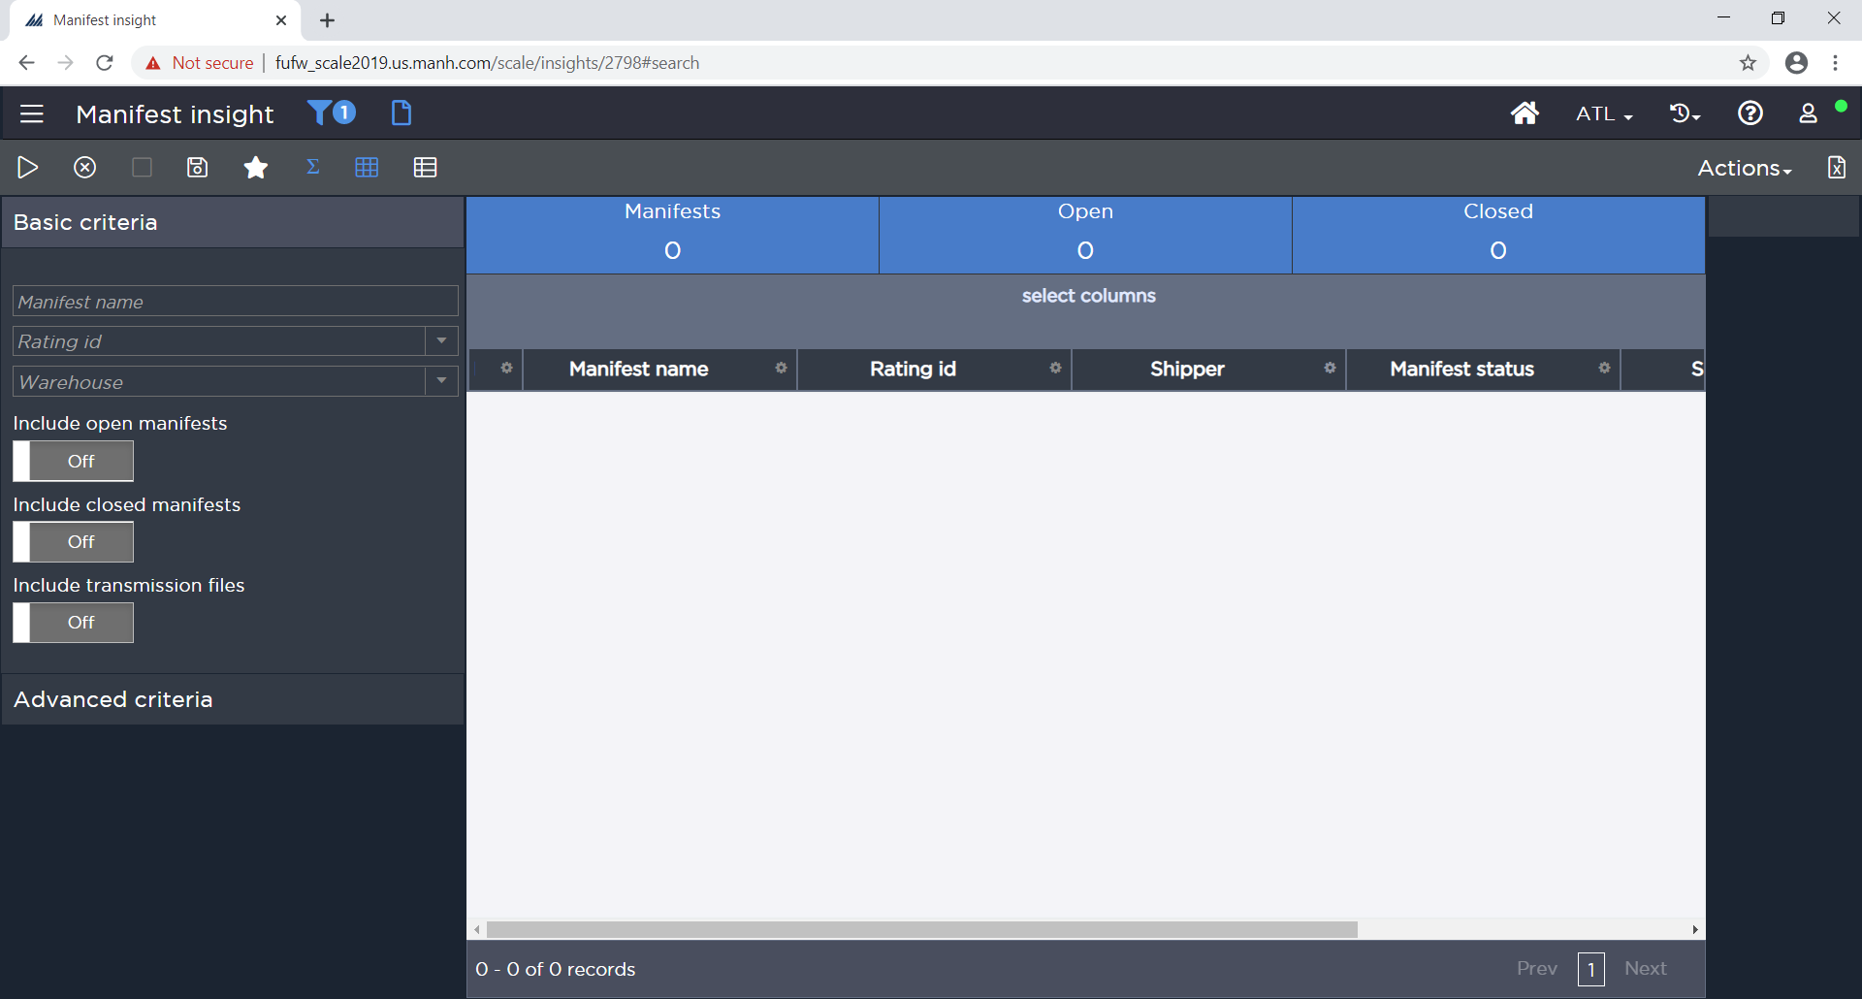
Figure: Manifest Insight Screen

Printing

Required documents can also be printed from the Manifest Insight. These documents can print out automatically when closing the manifest or be printed manually.

The documents include:

- Container Manifest
- UPS Summary Label

Once a Manifest has been closed, the Manifest is no longer open to receive additional containers; all additional containers manifested for that day are put on a new manifest, and Electronic Manifest is sent to Parcel Carrier.

Note: Containers on closed manifests may not be changed.

V. Performance Management SUMMARY

REPORTING REQUIREMENTS

VI. SYSTEM MODIFICATIONS

Extensions

Ext | Description | Approved?
EX01 | Custom Item Balance (Will handle displaying mixed inventory statuses at the Shipping Dock locations) | Approved

Documents

Modification | Description
DOC01 | Receiving Worksheet
DOC02 | 1348 Form
DOC03 | Bill of Lading

Labels

Modification | Description
LBL01 | Receipt Container Label
LBL02 | Container Contents Label
LBL03 | Parcel Shipping Label
LBL04 | Vendor Label

Exit Point

Modification | Description
EXP01 | Work Creation – After (used for wiping P&D on transfer into R1 locations)

Override Data Wave Steps

ODWS | Description

VII. OPEN ISSUES

- See comments throughout document. In later iterations of this document, we will move current issues into this section.

VIII. RESOLVED ISSUES

APPENDIX A - KEY CONFIGURATIONS

SCALE has various configurations that are key to defining processes and functionality in the system. Some of these are system wide values and others are functional area specific. This section outlines these key configurations.

SYSTEM KEY CONFIGURATION OVERVIEW

SCALE has sets of system values for various functional areas that define how the system interacts with users for these areas. This part of the documents outlines the key values and discusses why the values are set the way they are.

Inventory Control System Values
Inventory Control system values direct the way the system validates or processes inventory in the system.

Adj Type for Status Change during Transfer
This value indicates the transaction type that the system will assign for status change history, when the user performs a transfer action that involves a status change. This value is Status Change.

Adjustment type for Lot Status Change
This value defaults the Inventory Adjustment Type used when changing the Inventory Status of a Lot from the Lot Workbench. This value is Status Change.

Allow duplicate license plates across warehouses
This value indicates whether the system will be allowed to assign the same license plate ID in different warehouses. The value is set to No.

Allow Duplicate Serial Numbers?
This value indicates if you want to you allow different items to have duplicate serial numbers across the system. If this value is N, you will not be able enter a duplicate serial number for different items, regardless of its item/company designation. If this value is Y, the system will allow duplicate numbers to be entered for different items. Note that you must have this value set to Y before the Allow Duplicates Checkbox on the Serial Number Template Window will become active. The value is set to No.

Default Inventory Status for Adjustments
This value indicates the inventory status that defaults into the Inventory Management Window when adjusting inventory. You can create inventory statuses that meet your business needs in the Inventory Status Window. Examples of inventory statuses could be available (an item is available for picking and/or shipping) or held (an item is currently unavailable for picking and/or shipping). The value of this configuration is Available.

Delimiter used to ensure unique license plate IDs
This value indicates the character that you want the system to use when it needs to create an LPN ID that would otherwise be a duplicate of an existing LPN ID. For example, if you define this value as an ampersand (&) character, the system will append it to the end of the LPN ID in this manner: LP1234&000001. The value of this configuration is @.

Dock Location Separator Value
This value identifies the character that you want the system to use when displaying the concatenated dock location area/position value during yard management processing. Note that if you change the separator character and there are existing dock location records, these existing records will not be updated with the new character. The value of this configuration is -

Edit User Def Fields in RF Inventory Management?
This value indicates if you want the system to display User Defined Data screen in RF inventory management. This screen appears after you perform an inventory management action on an RF device. It allows you to associate text (such as a reason code or other text) to an inventory adjustment. The value is set to Yes.

Generate Cycle Count on Location Override Putaway
This flag is used to trigger a system directed Cycle Count of a location when the location is overridden during a Putaway. The value for this is Yes.

Generate Cycle Count on Location Override Pick
This value indicates that when the user overrides the pick location while performing work execution, the system will automatically generate an activity-driven cycle count request for the original pick location. The value for this configuration is Yes.

Inventory status for frozen lots
This value indicates the status that the system will apply for inventory that has been frozen from the Lot Workbench. This value is Held.

Location check digit format
This value specifies the format the system will use when generating automatic check digits. Use the following values to determine this format:
- B if you want the digit to be an alpha-numeric character.
- N if you want the digit to be a numeric character.
- Any other value (alpha or numeric) if you want it to be an alpha character.
- Non-character values, such as a / or a *, are considered alpha characters
Travis Check Digits are 3-character Aplha-numeric values.

Reuse Closed License Plates?
This value indicates whether the user will be allowed to enter a license plate ID that exists in the system but is in a closed status. This value is set to No.

Short Pick Inventory Action
This flag determines what happens when a user short-picks a shipment with a location that has inventory values. The value configured for Travis is Count, suspend transaction quantity so that the short pick does not create any inventory transactions that affect inventory, other than the setting of suspense quantity.

Should item be validated throughout system?
This flag is set to Yes so that the item is validated in all parts of the system. The item must be configured before it can be used in inventory, receipts, shipments and work

Should location be validated throughout system?
Each time an employee attempts to use a location on any window (except the Location Window), the system will reference the Location Validation flag. If you set the flag to No, the system will create locations automatically as the user identifies them through processing. The system will not validate these locations. If you set the flag to Yes, the system will require users to create locations on the Location Window. It will catch any misspellings or typos when a user attempts to access the location on another window. The value for this is set to Yes.

Show All Allocation Failures for Allocate Complete
This value indicates if, for a shipment that has the Allocate Complete setting active, you want the system to evaluate all of a shipment's details for shipment allocation when at least one shipment detail fails allocation. When there is an allocation failure, the system will update the shipment detail's Allocation Rejection Quantity value. You can view these allocation failures on the Shipment Detail Allocation Rejection Viewer. The value for Travis is Yes.

Use Location UM Overrides
This field determines if SCALE keeps track of Location level unit of measure records when the values are different than the tracked units of measure in configurations. The value for this field is set to No.

Whether inventory is being tracked by default
If you select the value "Yes," the system will allow adjustments for any item that is not defined in the system. If you select the value "No," then the system will not allow adjustments to any item not already defined in the system. The value for this configuration is Yes.

Write Location UM overrides on Item UM Change
This value tells the system whether to create Location Level Unit of Measure records if the system changes the dimensions or conversion quantity of an item that already exists in inventory. The value for Travis is set to No.

Receiving System Values
Receiving system values direct the way the system processes receipts in the system.

Locating Rule Assignment During
This value determines when SCALE runs the Locating Rule Assignment process. The value for Travis is Receipt Check In so that the rules are assigned as the product is being received.

Prompt for Receiving Preference in RF
This value indicates whether the system will always display the list of available receiving preferences whenever a user logs onto RF receiving (even if they have a default preference defined on their user profile). If this system value is set to No, then if a user has a default preference defined, then the system will not display this list of preferences. The value is set to Yes.

Rating System Values
Rating system values direct the way the system handles interaction with rating requirements.

Allow Multiple Manifests Per Day?
This value indicates whether the system will allow more than one manifest per day. The value for Travis is Yes to allow multiple parcel pickups / day.

Is Progistics installed?
This field denotes whether Progistics (third-party rating system that ships with SCALE if licensed). This also affects certain configurations that call into Progistics for information such as Print Devices and Shipper Code Cross Reference. The value for Travis is Yes as Progistics will be used for this implementation.

Machine/IP address hosting FedEx rating software
This value identifies the machine/IP address that is hosting the FedEx rating software. The value is N/A.

Print UPS Manifest default checked?
This value determines if the system will by default select the Print UPS Manifest Checkbox. This checkbox indicates if you want the system to automatically print a UPS manifest document after a manifest is closed. Set Value = N

Print UPS Summary Barcode Label default checked?
This value determines if the system will by default select the Print Summary Barcode Label Checkbox. This checkbox indicates if you want the system to automatically print a UPS summary barcode label after a manifest is closed. Set Value = N

Should carrier be validated throughout system?
This field determines whether carriers must be configured before they can be used. The value for Travis is set to Yes noting that any carriers that are defined or sent from the host must also be configured in SCALE.

Cycle Count System Values
Cycle Count System Values direct the way the system handles interaction with Cycle Counting functional requirements.

Activity Count - Negative Adjustment
This value tells SCALE which Inventory Adjustment Type is used when performing a negative inventory adjustment because of reconciling an Activity based cycle count. This value is CC.

Activity Count - Positive Adjustment
This value tells SCALE which Inventory Adjustment Type is used when performing a positive inventory adjustment because of reconciling an Activity based cycle count. This value is CC.

Auto Release Cycle Count Plan
The system uses this value to determine if you want the system to automatically release a plan, after a plan has been run using a scheduled job. The value is set to No. This is so that the counts can be reviewed before being sent to the floor for execution.

Create work for activity driven cycle count?
This value defaults whether the system creates work for Cycle Counts. Because the warehouse is handling cycle counting via the RF device, this value is set to Yes.

Planned Count - Negative Adjustment
This value tells SCALE which Inventory Adjustment Type is used when performing a negative inventory adjustment because of reconciling a Plan based (Quick Plan and Master Plan) based cycle count. This value is CC

Planned Count - Positive Adjustment
This value tells SCALE which Inventory Adjustment Type is used when performing a positive inventory adjustment because of reconciling a Plan based (Quick Plan and Master Plan) based cycle count. This value is CC

Work unit field for activity driven work
This value is used to set the work unit on activity [non-plan] driven requests (if you are creating work for these requests). The value is set to Internal Instruction Number.

Work System Values
Work system values direct the way the system handles interaction with Work functional requirements.

Container group removal when group work is passed?
This value determines if the system will remove all the containers from the picking group when the user elects to pass work during group user work execution:
- No: The system will not remove the containers.
- Warn: The system will display a confirmation message, and the user can then decide whether or not to remove the containers (on the message, the user would press "OK" to remove, press "Cancel" to pass the work without removing).
- Yes: The system will remove the containers

This value is for Travis is set to No

Delimiter used to ensure work units are unique.
This value identifies the delimiter character you want to use to ensure that each work unit in the system is unique. The value is set to #.

Display Comments during Work on RF?
This value determines whether the system will display comments during the RF picking process. These comments are defined on the Comment Type Window. Note that displaying these comments can slow down RF performance. The value is set to Yes.

Display Text Messages during Work on RF?
This value determines whether the system will display text messages during the RF picking process. These messages are defined on the Text Message Window. Note that displaying these messages can slow down RF performance. The value is set to Yes but does not mean that every pick has a text message. These messages need to be of high importance to interrupt the picking process.

Hide non-significant decimal positions on RF picking?
To help with limiting decimal positions in SCALE to only what is required, the flag for hiding any non-significant decimal positions on the RF is set to Yes.

Hold code assigned to work until wave released
This value denotes what value is displayed for all work created during the wave that is still on hold until released. The value for Travis is Wave Not Released.

Max Work records retrieved in System Directed Work
This value helps keep the number of records to a minimum when retrieving work units for a specific work profile. This value is currently set to 2000 and should only be changed if the number of open work units exceeds this amount for the same priority. It is not anticipated that this value will need to be changed from its default.

Number of locations to display on Override Pick
This value determines the number of locations that are displayed if the user views the Location Lookup screen on RF Work Execution. The value defaults to 10 and should remain this way unless there is a business reason that more locations are displayed

Override Work Type value for replen work from wave
This value allows the work type that is specified to be applied to any replenishment work created in a wave. The system will assign this work type (and its priority) to the wave-generated replenishment work. This is helpful when wanting to distinguish between replenishment work created by the wave and replenishment work created manually. This value is TBD

RF Session Timeout value (in minutes)
This value defaults the timeout period in minutes for the RF session. The default value is set to 720 minutes. This value should not be changed unless volume testing / integration testing proves that this value needs to be updated.

Text displayed if current pick will empty location
This value identifies the text message that the system will display if the current pick will empty a location. The value for this is the default Pick Empties Location.

Inbound Status Flow

Inbound Status Flows define how receipts move through the different steps in the system. The system has a default status flow for Inbound and the system allows for Custom Status Flows to be used to have receipts flow through the system different than the default.

Default Status Flow
Below are the statuses that are used in SCALE for receipts.

Status Name | Status Code | Comment
Check In Pending | 100 | The Receipt is Pending Check In. No Receipt Containers created (unless downloaded in interface)
Locate Pending | 200 | The LPN is sitting on the Receiving Dock, but has not yet been located.
Putaway Pending | 300 | LPN has been located and work has been created but not yet started.
In Putaway | 301 | LPN is in the process of being Putaway
Closed | 900 | The LPN is closed.

Outbound Status Flows

Outbound Status Flows define how shipments move through the different steps in the system. The system has a default status flow for Outbound (Found under the Functional Area configuration in SCALE), and the system allows for Custom Status Flows to be used to help process shipments that need to deviate from the default flow.

Below are the statuses that are used in SCALE to move shipments through the system.

Status Name | Status Code | Comment
In Pool | 100 | Order is in the Wave Explorer / Pool folder
Wave Pending | 200 | Sitting in the Wave Explorer / Active Wave but the Wave is not Running
In Wave | 201 | Part of an Active Wave
Picking Pending | 300 | Wave Complete, awaiting Picking
In Picking | 301 | In process of picking order
Packing Pending | 400 | The item is picked but is currently at the Pack Stations
In Packing | 401 | The item is packed inside the Container, but the Container hasn’t been closed yet
Staging Pending | 600 | The item is packed inside the container and container is closed. Container is currently at packing location and ready to be moved to a Staging location.
Loading Pending | 650 | Inventory is sitting at Packing / Staging location. Ready to be moved to a Dock Door.
Ship Confirm Pending | 700 | Inventory is sitting in pack / Dock Door Location, shipment ready for shipping.
Load Confirm Pending | 800 | Shipment has been confirmed as being shipped. No changes can be made at this point.
Closed | 900 | Shipping Load and Shipment Closed.

Inbound Status Actions
The Inbound Status Actions define the status of Receipts, Details and Containers as certain events occur in the system.

Default status when adding a receipt container
When a new Receipt Container is added to the system, SCALE sets the status of this new container as Locate Pending.

Default status when adding a receipt
When a new Receipt is added to SCALE either manually or via the interface, this value sets the status of those receipts. For Travis, the status is set to Check In Pending.

Default status when check in is cancelled
When an LPN Check In is cancelled, SCALE sets the status of the receipt back to Check In Pending.

Default status when locating is cancelled
When an LPN is un-located in SCALE, the status of the LPN is set back to Locate Pending.

Outbound Status Action
The Outbound Status Actions define the status of shipments, details and containers as certain events happen.

Default status when shipment is cancelled
This value tells SCALE to return any shipment that needs cancelling back to In Pool status.

Default status when shipment is rejected
This value tells SCALE how to handle rejections that occur during the Wave Allocation process. The value is configured as In Pool.

Default Status for Short Pick
This value tells SCALE how to handle quantity that has been rejected due to a short pick during Work Execution. This value is configured as Delete Rejected so that any quantity that is shorted is rejected on the shipment detail/deleted from the order and uploaded to the host.

Decimal Positions
The Decimal Positions configurations are used when displaying various types of numeric based values in the system.

Value Type | Number of Decimals Displayed
Default | 0
Dimension | 2
Quantity* | 0
Value | 2
Volume | 3
Weight | 2

NOTE: For Quantity, if the value is zero then the Resource Files for QTY and QUANTITY need to be updated to have zero or the number of decimals for use when inputting quantities. The SDK has a script for configuring this via SQL Server.

Interface System Values
Interface System Values define how SCALE handles values for interfacing shipments, receipts, and all other utilized interface touchpoints.

Allow Duplicate Receipt IDs On Add?
This value indicates if the system will allow the same receipt ID to exist multiple times in the system. If you select 'Y', the system will allow the interface to download receipt ID's that already exist in the database. If you select 'N', the system checks to see if this receipt ID already exists in the database. If it does, the system will reject the receipt and display an error message saying that the ID already exists and system will not allow duplicates. The value for Travis is set to N.

Allow duplicate Shipment IDs On Add?
This value indicates if the system will allow the same shipment ID to exist multiple times in the system. If you select 'Y', the system will allow the interface to download shipment ID's that have the same shipment ID/warehouse/company. If you select 'N', the system checks to see if this shipment ID/warehouse/company already exists in the database. If it does, the system will reject the shipment and display an error message saying that the ID already exists and system will not allow duplicates. The value for Travis is set to N.

Allow Zero in UD7 and UD8 On Download?
This value indicates if you want the system to change the value for User Defined Fields 7 and 8 to a zero value when it is sent as part of a download interface save or change. If this setting is not activated, then the system will consider an interfaced zero value as no change to these user defined fields, and they will keep their original values. The value for Travis is set to Y.

Include 0 Inventory Items In Item Balance Upload?
This value indicates if the system will include a record for items that have zero quantity currently in the warehouse. This value is set to No.

Input Directory for Interface File Downloads
This value indicates the path of the directory that the system will look for delimited/fixed length/XML files to interface. Note that you will need to get your files into this directory by some means so that the interface can process them. The value for Travis is \\<<Storage Blob>>\ILS\Interface\Input.

Interface Error File Output Directory
This value is used to indicate the path of the directory where the system will place error files generated during the download process. Processed files that are kept are also placed in this folder. The value for Travis is \\<<Storage Blob>>\ILS\Interface\Output.

Interface XSL Files Location
This value indicates the path of the directory where the .xsl style sheets (that the system uses to transform data to SCALE-formatted XML) are located. The value for Travis is \\<<Storage Blob>>\ILS\Interface\XSL.

Output Directory for Interface File Uploads
This value is used to indicate the path of the directory where files that are to be uploaded by SCALE reside. For delimited/Fixed Length/XML interface modes, the system places the data files in this directory by default. The value for Travis is \\<<Storage Blob>>\ILS\Interface\Upload.

Receiving Upload Level
Receiving Upload Level: This value indicates what level (container, detail, or header) is checked for status during an upload.
- Container: Produces data (receipt container level) as soon as the container reaches the upload status, and the container is closed.
- Detail: Produces data (receipt container/detail level) when all other containers on the same receipt detail have reached the upload status, and the detail is closed.
- Header: Produces data (receipt container/detail/header level) when all other containers on all receipt details have reached the upload status, and the header is closed.

This Value for Travis is set at Container.

Shipping interface download record types to create
This value determines what records the system will create when it downloads orders from the ERP. The system can generate shipments, or shipments and orders. Shipments are required to process records in the system. Trading Partner Management displays records based on order number, so if you are using this module, select the Shipments and Orders option. The value configured for Travis is Shipments.

Split Consolidated Shipments on Upload?
This value indicates that for consolidated shipment uploads, the interface upload process will split the shipment based on unique ERP Order values. In other words, if you interface down multiple orders and then SCALE consolidates them, the system will interface the orders back up in the same format as they came down in.

To achieve this result, you must interface a value in the ERP_ORDER field on each shipment detail that is unique to that order. The upload interface process will use this to break apart the shipments. If you do not interface this value, the system will automatically set this field to the shipment ID interfaced. Additionally, note that shipping containers still get tied to a single shipment during the upload, since they could conceivably have mixed orders inside of them, or could be nested onto a pallet with other orders.

The value for Travis is N.

Status That New Receipt Records Are Placed In
This value identifies the status that the system will assign to interfaced receipt headers/details/containers. The value configured for Travis is Check In Pending.

Status That New Shipping Records Are Placed In
This value identifies the status that the system will assign to interfaced shipment headers, details and containers. The value for Travis is In Pool.

Upload Closed Receipts With 0 Qty Received
This value indicates that you want the receipt upload interface to upload closed receipts when no quantity has been checked in on the receipt (i.e. a receipt that has been manually closed before any receipt containers were checked into the system). This Value is set to Yes.

Upload Deleted Shipments?
This value allows the upload of deleted shipments when performing a Shipping Upload. These shipments could have been deleted from allocation rejection or short picking when using the "Delete Rejected" Outbound Status Action; or, via manual deletion. Note that the system places the shipment's header and detail information in the UPLOAD_ORDER_HEADER and UPLOAD_ORDER_DETAIL tables until the upload is processed. This value is at Travis is set to Yes.

Upload Receipt Containers At This Status Or Higher
This value identifies what status a receipt header must meet before the system can include its receipt header in an upload file. This file provides information about the status of interfaced receipts in the system. This value is at Travis is set to In Putaway.

Upload Receipt Details with 0 Quantity Received
This value indicates whether you want receipt detail lines (with zero quantity) uploaded by the interface. When this value is set to "yes," then the system will upload these details, but only if the Close Date value on the receipt header is filled (which indicates that the customer is done receiving against this receipt). This value at Travis is set to Yes.

APPENDIX B – SECURITY PERMISSIONS

Travis can create user security records on the Security Permissions Window. When a user attempts to access a SCALE window, the system determines if they have any user-level security records. If an employee has a user-level record, the system will apply that record each time the employee attempts to access the window. User-level security limits a single employee's ability to access and/or perform actions on a specific window. Or the Security Permissions Window can be used to define the security rights of a specific security group. Processing and/or configurations are defined for the security group and what security checkpoints can be used for the group. These are all defined using the Security Permissions Window.

Mass security changes are also allowed using this window. The system allows you to select the processing or configuration windows and assigning security to them. All the selected forms (windows) will be assigned the selected security levels and actions.

This window allows you to grant security permissions by a specific processing function or by a specific configuration.

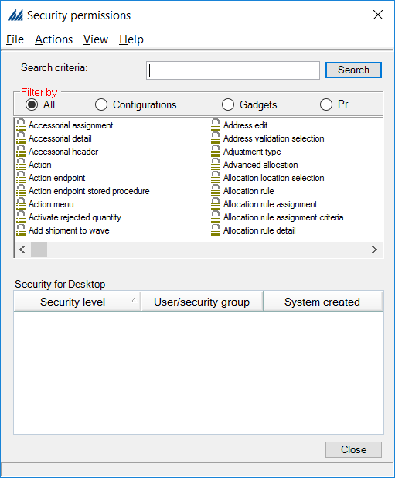
Figure: Security Permission Configuration Window

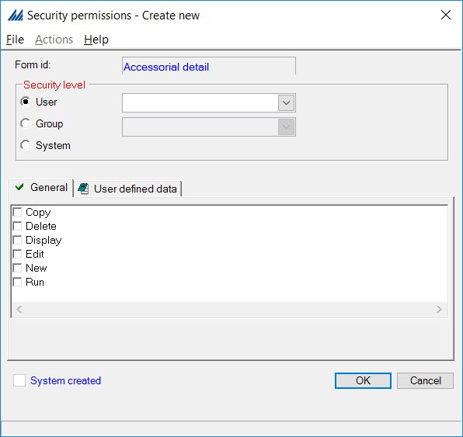
Figure: Security Permission at Form Level

REVISION HISTORY

Date: | Changed By: | Doc. Version: |  | Notes:
05/17/2022 | Maxwell Colter |  | 1.0 | Original Document

ACKNOWLEDGEMENT of Functional Flow SIGNATURE – Version 1.0

Signature: _____________________________________ Date: ____________

